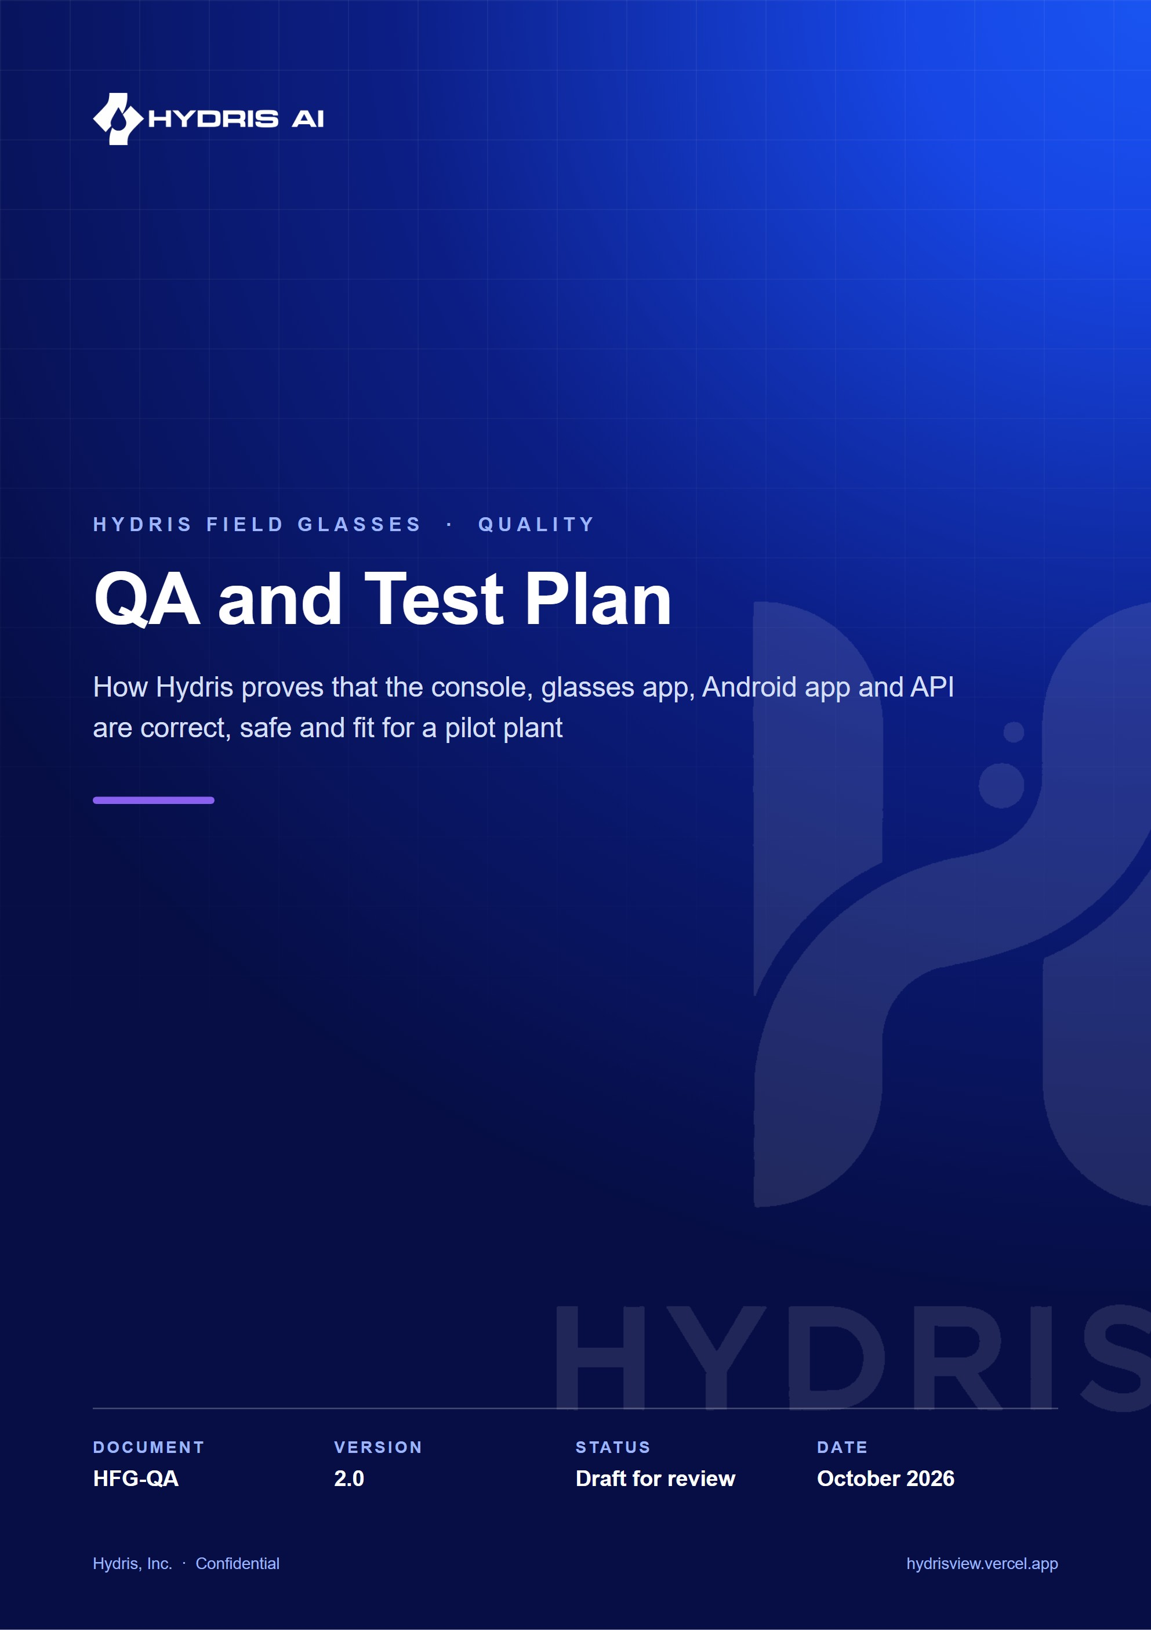
Document control
Document | QA and Test Plan (HFG-QA)
Version | 2.0
Status | Draft for review
Owner | Quality engineering, Hydris
Audience | QA, engineering, product, pilot customer quality and EHS leads
Product | Hydris Field Glasses: website, operator console, glasses app, Android app, API
Source of truth | docs/product/QA_TEST_PLAN.md in tarun-km/hydrisview (this Word file is generated from it)
Classification | Confidential: Hydris, Inc. and named partners
Revision history
Version | Date | Author | Changes
2.0 | October 2026 | Quality engineering, Hydris | Expanded edition with coverage inventory, Given/When/Then acceptance criteria per feature, OCR and voice test set design, hardware matrix, non-functional targets, defect workflow, release gates and traceability

Contents
1 Purpose, scope and principles 5
1.1 What this plan covers 5
1.2 Out of scope 6
1.3 Quality principles 6
2 Quality strategy and test pyramid 7
2.1 Levels of testing 7
2.2 Entry and exit for each level 9
3 Current automated coverage 10
3.1 Summary 10
3.2 Domain package: packages/domain/test 10
3.3 API: apps/api/test 12
3.4 Browser journeys: tests/e2e/journeys.spec.ts 14
3.5 Coverage map and known gaps 15
4 Test environments and data 17
4.1 Environments 17
4.2 Demo mode as a test environment 17
4.3 Accounts and seed data 18
4.4 Test data sets 18
5 Manual test charters by surface 19
6 Hardware and device matrix 21
6.1 Matrix 21
6.2 Environmental conditions 22
7 Acceptance criteria by feature 23
7.1 Glasses pairing 23
7.2 Demo accounts and demo mode 24
7.3 Alarms 25
7.4 Inspections and maintenance 27
7.5 Audit scanning 28
7.6 Voice assistant 32
7.7 Android app 35
7.8 Glasses web app layout and overlap checks 35
8 Non-functional testing 37
8.1 Performance 37
8.2 Load and soak 37
8.3 Security testing 37
8.4 Accessibility 38
8.5 Field trials 38
8.6 Battery and thermal on glasses 39
9 Defect management 40
9.1 Defect workflow 40
9.2 Severity and priority 41
10 Release quality gates and pilot exit criteria 42
10.1 Gates 42
10.2 Pilot exit criteria 43
10.3 Exit criteria for general availability 43
11 Traceability from requirements to tests 45
12 Proposed CI test pipeline 48
13 Quality metrics dashboard 51
14 Risk-based testing 52
15 Schedule, roles and open questions 54
15.1 QA schedule 54
15.2 Roles 54
15.3 Open questions 54

Hydris Field Glasses is used where a wrong number has consequences: a discharge reading that reaches a regulator, an alarm that is acknowledged but never resolved, a lab sheet whose decimal point moved during scanning. This plan describes how quality is built in and proven for every surface of the product: the operator console, the glasses web app and its simulator, the native Android app "Hydris Field", the API and the public website.
The plan separates what exists today from what is proposed. Every statement about the current product names the test file or source file it comes from. Counts in this document come from running npm test at the repository root on 22 October 2026 against commit 07cca23. Targets are labelled as targets; nothing in this plan is a measured field result unless it says so.
71  automated tests on main  26 domain, 41 API, 4 Playwright journeys |  | 67 / 67  unit and API tests passing  `npm test`, 22 Oct 2026 |  | 0  CI pipelines  No `.github/` directory yet |  | 0  Android unit tests  Manual verification on a Pixel 7 emulator only

1 Purpose, scope and principles

1.1 What this plan covers
This plan is the single reference for test strategy, environments, acceptance criteria, non-functional testing, defect handling and release gates for the Hydris Field Glasses platform up to and including the first customer pilot. It is written for the people who will execute it (QA and engineering), the people who rely on it (product, customer success) and the people who will audit it (pilot customer quality, EHS and IT security leads).
Table 1. Surfaces and components in scope
Surface or component | Location in the repository | Primary users | Test levels that apply
Domain rules (roles, alarms, workflows, units, audit structuring, voice parsing) | packages/domain/src | All surfaces | Unit
API (Fastify, Drizzle, Postgres or PGlite, RLS) | apps/api/src | All clients | Integration, contract, security, load
Operator console | apps/web/src/console, apps/web/src/app/console | Supervisors, managers, admins | E2E, accessibility, exploratory
Glasses web app and simulator | apps/web/src/glasses, /glasses, /simulator | Field operators | E2E, layout, field trial
Audit scanning (browser) | apps/web/src/lib/docdetect.ts, ocr.ts, GuidedCapture.tsx | Operators, verifiers | Unit (proposed), accuracy benchmark, manual
Native Android app "Hydris Field" | apps/android | Operators, engineers | Unit (proposed), instrumented UI (proposed), manual, field trial
WebView bridge companion | apps/glasses-bridge-android | Legacy bridge path | Contract parity, manual
Public website and enquiry form | apps/web/src/app/(site) | Prospects | Smoke, accessibility
Deployment (Vercel, demo mode, cron) | vercel.json, apps/api/src/serverless.ts, apps/api/src/jobs.ts | Platform engineering | Smoke, configuration tests

1.2 Out of scope
- Control of plant equipment. Hydris is read-only to the plant (see Security and Privacy), so there is no PLC, SCADA or DCS write path to test. Tests assert that no such path exists.
- Validation for FDA-regulated GxP use. Hydris applies Part 11 concepts (audit trail, four-eyes approval) but is not a validated system, and this plan does not produce an IQ/OQ/PQ package.
- Meta firmware, the Meta AI app and the Wearables Device Access Toolkit (DAT) themselves. They are treated as dependencies whose behaviour is observed and recorded, not tested.

1.3 Quality principles
- Missing data is never a value. Any test that touches telemetry must check freshness states (live, delayed, stale, no_data) and assert that a missing reading never renders as a number.
- Acknowledgement is not resolution. Alarm tests check that each lifecycle step is separate, permissioned and audited.
- Machines propose, people verify. OCR and voice outputs are suggestions until a person confirms them. Tests assert that unverified values cannot reach an approved record.
- Tenancy is enforced twice. API role checks and Postgres row-level security are both tested, including queries without a WHERE clause.
- Deterministic first. Demo seeds and simulation scenarios are deterministic, so a failing test reproduces.
- Field reality wins. A feature is not pilot-ready until it has passed a trial with gloves, noise, sunlight and a weak network on the real hardware.

2 Quality strategy and test pyramid

2.1 Levels of testing
The strategy follows a conventional pyramid weighted towards fast, deterministic tests on the domain package and the API, with a thin layer of browser journeys and a deliberate, structured layer of manual and field testing on top. Field testing is not an afterthought for this product: glasses, gloves and plant noise create failure modes that no emulator reproduces.
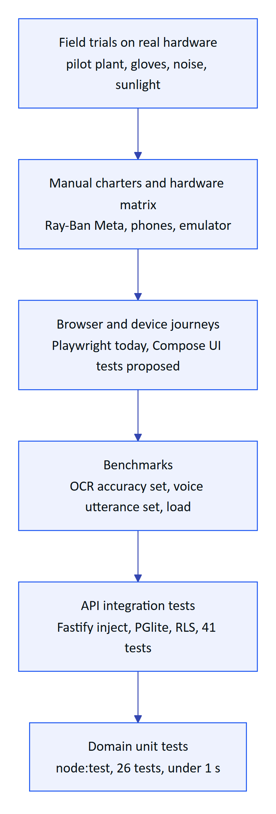
Figure 1. Hydris test pyramid: fast deterministic tests at the base, field trials at the top
Table 2. Test levels, tools and ownership
Level | Tooling | Runs where | Typical duration | Owner | Status
Domain unit | node:test with tsx, packages/domain/test | Laptop, CI (proposed) | Under 1 s (728 ms measured) | Engineering | Built
API integration | node:test, Fastify app.inject, PGlite in memory, apps/api/test | Laptop, CI (proposed) | About 75 s (73.4 s measured) | Engineering | Built
Browser journeys | Playwright 1.64, tests/e2e/journeys.spec.ts, local Chrome channel | Laptop with dev stack | 2 to 4 min (estimate) | QA | Built (4 journeys)
Android unit and UI | JUnit, Compose UI test, Robolectric (proposed) | Gradle, emulator | To be measured | Mobile | Planned
OCR accuracy benchmark | Ground-truth set plus scoring script (proposed) | Laptop, nightly | 10 to 20 min (estimate) | QA, ML | Planned
Voice utterance benchmark | Recorded and synthetic utterances plus scoring script (proposed) | Laptop, nightly | 10 min (estimate) | QA | Planned
Load and soak | k6 (proposed) | Staging | 30 to 60 min | Platform | Planned
Security | OWASP ZAP baseline, tenant fuzzing, npm audit, MobSF (proposed) | Staging, CI | 15 to 45 min | Security | Planned
Accessibility | axe-core with Playwright, TalkBack, manual (proposed) | Laptop, device | 15 min | QA, design | Planned
Manual charters | Session-based exploratory testing | Lab, emulator, devices | 60 to 90 min per charter | QA | Partial (ad hoc today)
Field trials | Scripted rounds at a pilot site | Pilot plant | Half day per trial | QA, customer success | Planned

2.2 Entry and exit for each level
- Domain and API: every pull request (once CI exists) must keep all tests green. New behaviour in packages/domain/src or an API module ships with tests in the matching file.
- Journeys: run before every deployment to the pilot environment and after any change to authentication, pairing, routing or the glasses shell.
- Benchmarks: run nightly and before every release candidate. A regression beyond the tolerance in Audit scanning or Voice assistant blocks the release.
- Manual and field: run per release candidate against the hardware matrix, with the charter list in Manual test charters.

3 Current automated coverage

3.1 Summary
The repository has 71 automated tests in three suites. npm test runs the domain and API suites; Playwright runs the browser journeys against a running development stack (npx playwright test, which starts npm run dev through the webServer block in playwright.config.ts and uses the local Chrome channel unless CI is set). The Playwright suite was not executed for this edition; its last recorded state is the "E2E: exact password locator, deterministic inspection ordering" fix in commit f77464d.
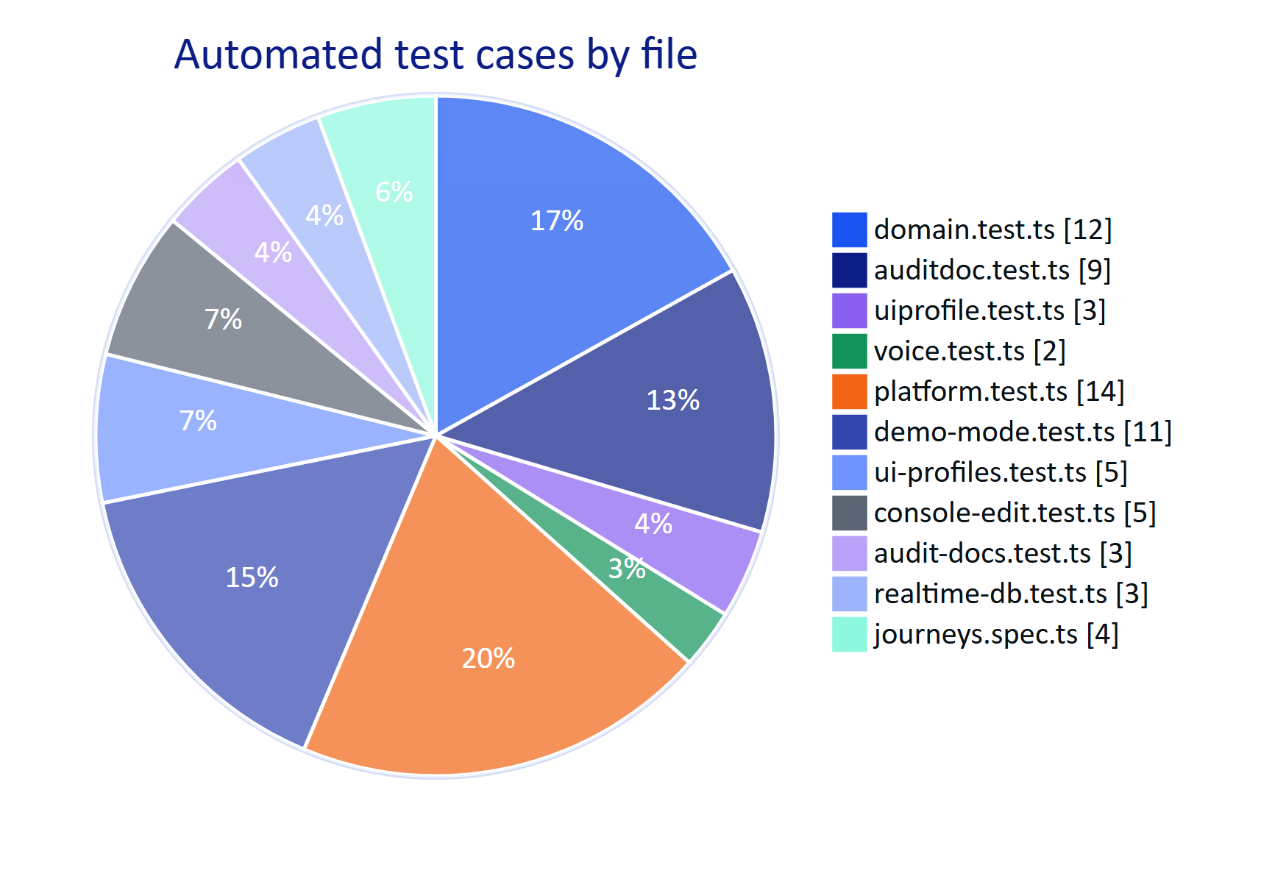
Figure 2. Automated tests on main by suite and file (count of test cases, 22 October 2026)

3.2 Domain package: packages/domain/test
These tests exercise pure functions with no database or network. They are the fastest feedback loop and the right home for any rule that can be expressed without I/O.
Table 3. domain.test.ts scenarios (12 tests)
Test name (abridged) | What it proves | Source under test
permission matrix: least privilege | Each role has only the permissions in the matrix; viewers cannot mutate | roles.ts
role assignment never escalates | assignableRoles never lets an inviter grant a role above their own | roles.ts
unit normalization converts and validates | Measurand units convert to canonical units; invalid units are rejected | measurands.ts
freshness never treats missing data as a value | live, delayed, stale, no_data derived from timestamps; missing data has no value | measurands.ts
threshold evaluation with deadband (hysteresis) | Values oscillating inside the deadband do not re-trigger | alarms.ts
on-delay suppresses transient breaches | A breach shorter than the on-delay raises no alarm | alarms.ts
alarm lifecycle: acknowledgement is not resolution | Transitions follow ALARM_TRANSITIONS; resolve needs a note and cannot start from active | alarms.ts
inspection and maintenance state machines | INSPECTION_TRANSITIONS and MAINTENANCE_TRANSITIONS allow only legal moves | workflows.ts
step outcome and progress | Step results (pass, fail, reading, choice) roll up into progress correctly | workflows.ts
device state derivation | Device state from record status, last seen and session | devices.ts
pairing codes: format and normalization | 8 characters from PAIRING_CODE_ALPHABET, display grouping, lower case and separators normalized | devices.ts
scenarios are deterministic and produce expected excursions | Simulation scenarios generate the same series every run and include the designed breaches | scenarios

Table 4. auditdoc.test.ts scenarios (9 tests)
Test name (abridged) | What it proves
key/value lines become typed fields with units | Outlet pH: 7.4 becomes a number field; 412 mg/L keeps its unit; dates and text are typed
aligned rows become a table with header | Rows aligned by x position become a table with a header row
two OCR passes cross-check values | A numeric disagreement (7.4 vs 7.1) is a mismatch; a one-letter name difference is close; O and 0 fold in numbers
helpers | splitUnit, similarity, reviewProgress behave as documented
decimal points matter; thousands separators do not | 7.4 vs 74 is a mismatch; 18,857 vs 18857 is a match
table columns returned as separate OCR blocks are re-joined | Column-wise OCR output becomes row-wise table data
values both engines agree on are still range-checked | pH 71 agreed by both passes is still flagged as implausible (dropped decimal)
table cells are range-checked; a matching labelled value is offered as the fix | An implausible cell is flagged and a labelled value elsewhere on the page is suggested
label and value columns returned as separate lines (ML Kit) pair up by visual row | Android ML Kit output, where labels and values arrive as separate blocks, pairs correctly

Table 5. uiprofile.test.ts and voice.test.ts scenarios (5 tests)
File | Test | What it proves
uiprofile.test.ts | precedence device > user > role > org | The most specific usable profile wins; unusable profiles fall through
uiprofile.test.ts | normalization keeps required screens and fills defaults | A profile cannot hide required screens; missing settings take defaults
uiprofile.test.ts | measurement filter/order and diff summary | Measurement lists honour filters and order; the diff summary lists changes
voice.test.ts | wake phrase variants and the question after it | WAKE_RE accepts "hey Hydris" and common mis-transcriptions (hydras, hydrus, idris) and extracts the question
voice.test.ts | measurand detection prefers specific phrases | "outlet pH" beats "pH"; filler words are ignored

3.3 API: apps/api/test
API tests boot the real Fastify application with an in-memory PGlite database, run the real migrations including the row-level security policies in drizzle/0001_rls.sql, and drive it through app.inject. Shared setup lives in apps/api/test/helpers.ts.
Table 6. platform.test.ts scenarios (14 tests)
Test | Requirements exercised
no session, no data: data endpoints reject anonymous calls | Authentication on every data route
login, refresh rotation, reuse detection, logout invalidates access immediately | FR-001, FR-003, FR-009
database boundary: RLS isolates tenants even without WHERE clauses | FR-008
API tenant isolation and invitation onboarding of a second organization | FR-004, FR-006, FR-008
role-based access including privilege escalation attempts | FR-004, FR-007
gateway ingestion: normalization, idempotency, validation and alarm generation | FR-021, FR-022, FR-030
alarm lifecycle: acknowledgement separate from resolution, permissions enforced | FR-031, FR-032
glasses pairing, inspection on glasses, sync to console, review, revocation | FR-040 to FR-042, FR-050 to FR-053
expired and denied pairing challenges cannot be used | FR-050
deactivated members lose access immediately | FR-009
password reset via e-mailed single-use token | FR-005 (token flow; email transport is not wired)
deterministic simulation scenario drives alarms through the real pipeline (demo tenant only) | FR-084
public enquiry: validation, consent and spam controls | Website enquiry form
overview and reports are scoped and exportable | FR-025, FR-081

Table 7. demo-mode.test.ts scenarios (11 tests)
Test | What it proves
demo defaults | DEMO_MODE yields an in-memory database, the demo flag, REALTIME_MODE=db and the simulator on
owner logs in | The owner account is org admin of the demo org and platform admin
seeding is deterministic across instances | Two cold starts create identical IDs, so tokens and links survive instance changes
overview, reports, assist, telemetry history and UI profiles have content | The seed is rich enough for a demonstration
a token issued on one instance is accepted on another | Cross-instance access tokens in demo mode
glasses paired on one instance work on another | Device rebuilt from token claims
lazy ticker advances live data through the ingestion pipeline | Simulation without cron on serverless
demo guest: named account works on every instance and owns personal work | POST /auth/demo named guests
demo pairing across instances, guest name and tasks, logout and re-pair cycles | Pairing state shared through the demo store
demo audit scans are visible and reviewable from every instance | Audit snapshot sharing
voice assistant answers from the connected account (user and paired glasses) | FR-071, FR-072 with the rules engine

Table 8. ui-profiles.test.ts, console-edit.test.ts, audit-docs.test.ts and realtime-db.test.ts scenarios (16 tests)
File | Test | Requirements
ui-profiles.test.ts | only org_admin edits; factory_manager reads; operators denied | FR-054
ui-profiles.test.ts | device context defaults to built-in profile | FR-054
ui-profiles.test.ts | publish versioning, SSE to affected devices, enforcement, rollback | FR-054, FR-080
ui-profiles.test.ts | precedence via the effective endpoint | FR-054
ui-profiles.test.ts | assignment validation and cross-tenant isolation | FR-008, FR-054
console-edit.test.ts | readings list exposes provenance; manual entries record who entered them | FR-023
console-edit.test.ts | corrections are append-only, validated, permissioned, drive history and latest value | FR-024
console-edit.test.ts | cross-tenant correction attempts and history lookups return 404 | FR-008
console-edit.test.ts | asset and sensor archive and restore with validation, permissions and history | FR-020
console-edit.test.ts | templates, tasks, rules and documents: edit, status changes and history | FR-030, FR-040, FR-043, FR-082
audit-docs.test.ts | capture, review, verify, independent approval, PDF | FR-061 to FR-066
audit-docs.test.ts | self-approval only in demo tenants (recorded); viewers cannot capture | FR-065
audit-docs.test.ts | vision output is cross-checked against OCR text inside each value box | FR-063
realtime-db.test.ts | DB mode: events persisted after the request and filtered per principal | FR-080
realtime-db.test.ts | realtime_events is not visible in tenant context | FR-008, FR-080
realtime-db.test.ts | cron job pass prunes old events and reports each job | Background jobs

3.4 Browser journeys: tests/e2e/journeys.spec.ts
Table 9. Playwright journeys (4 tests)
Journey | Steps | Requirements
anonymous visitors cannot reach the console | Open /console, expect redirect to /login | Authentication
sign in, overview, logout invalidates the session | Sign in, see the overview, log out, confirm the old session no longer works | FR-001, FR-003
glasses pairing by code, guided inspection on glasses, revocation | Second browser context opens the glasses app, reads the code, the console approves it, the operator completes an inspection, the admin revokes the device | FR-041, FR-050, FR-052
operators cannot reach administration they lack permission for | Operator signs in and is blocked from admin pages | FR-007

3.5 Coverage map and known gaps
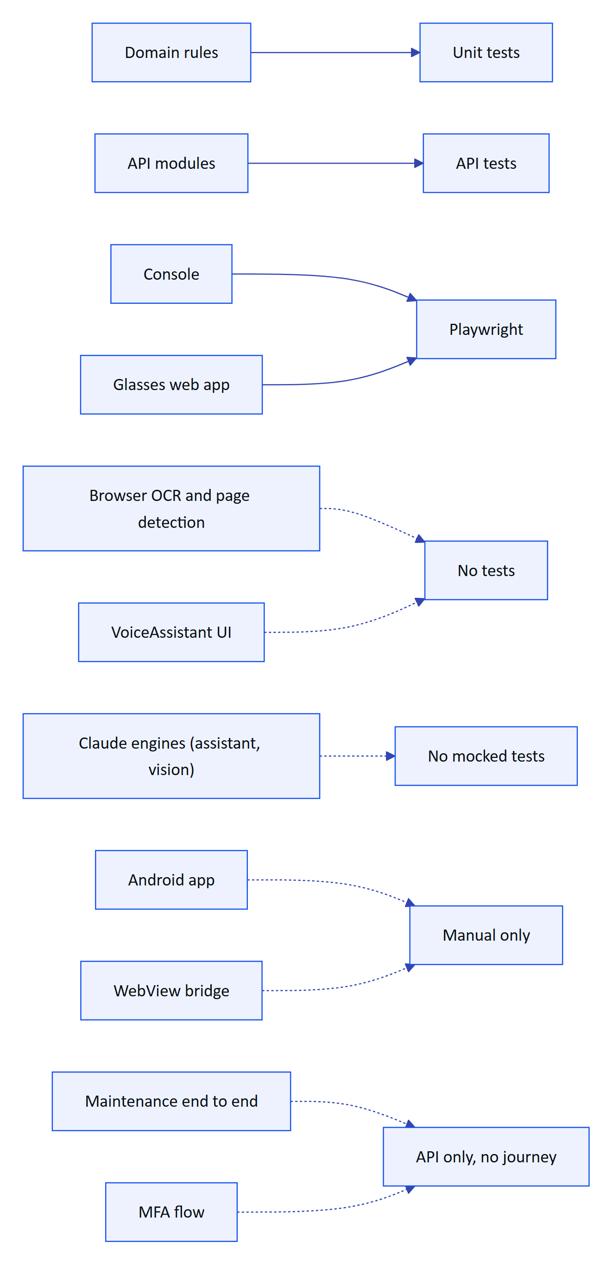
Figure 3. Where automated coverage exists today (solid) and where it is missing (dashed)
Table 10. Automated coverage gaps and the proposed fix
Gap | Risk if left | Proposed test | Priority
docdetect.ts and ocr.ts run only in the browser | Page detection or pass enhancement regress silently | Node unit tests with canvas fixtures (@napi-rs/canvas) and a stored set of frames | P1
GuidedCapture and AuditScan.tsx UI | Auto-capture never fires, or fires on a blurred frame | Playwright with a fake camera stream (--use-file-for-fake-video-capture) | P1
VoiceAssistant.tsx UI | Wake phrase ignored or card cannot close | Playwright with a stubbed SpeechRecognition | P2
/assistant/ask with the Claude engine | Tool misuse, a number not present in facts | API test with a mocked Anthropic client returning scripted tool calls | P1
Vision engine for audit scans | Vision text accepted without the OCR cross-check | API test with a mocked vision response that disagrees with OCR | P1
Android app (apps/android) | Regressions found only by hand | JUnit for OcrEngine parsing and DocDetect, Compose UI tests for login, home, alarms, scan | P1
Maintenance actions end to end | Hold, complete, reopen broken in the UI | Playwright journey | P2
MFA enrolment and step-up | Lockout of admins | Playwright journey with a TOTP helper | P2
Accessibility | WCAG 2.2 AA failures on console and mobile | axe-core in Playwright, Android Accessibility Test Framework | P2
Load | Ingestion or SSE fall over at pilot scale | k6 scripts | P2

IMPORTANT
The single biggest quality gap is not a missing test but the missing CI pipeline. Tests that only run on a laptop decay. The proposed pipeline in Proposed CI test pipeline is the first task of the hardening phase in the Roadmap.

4 Test environments and data

4.1 Environments
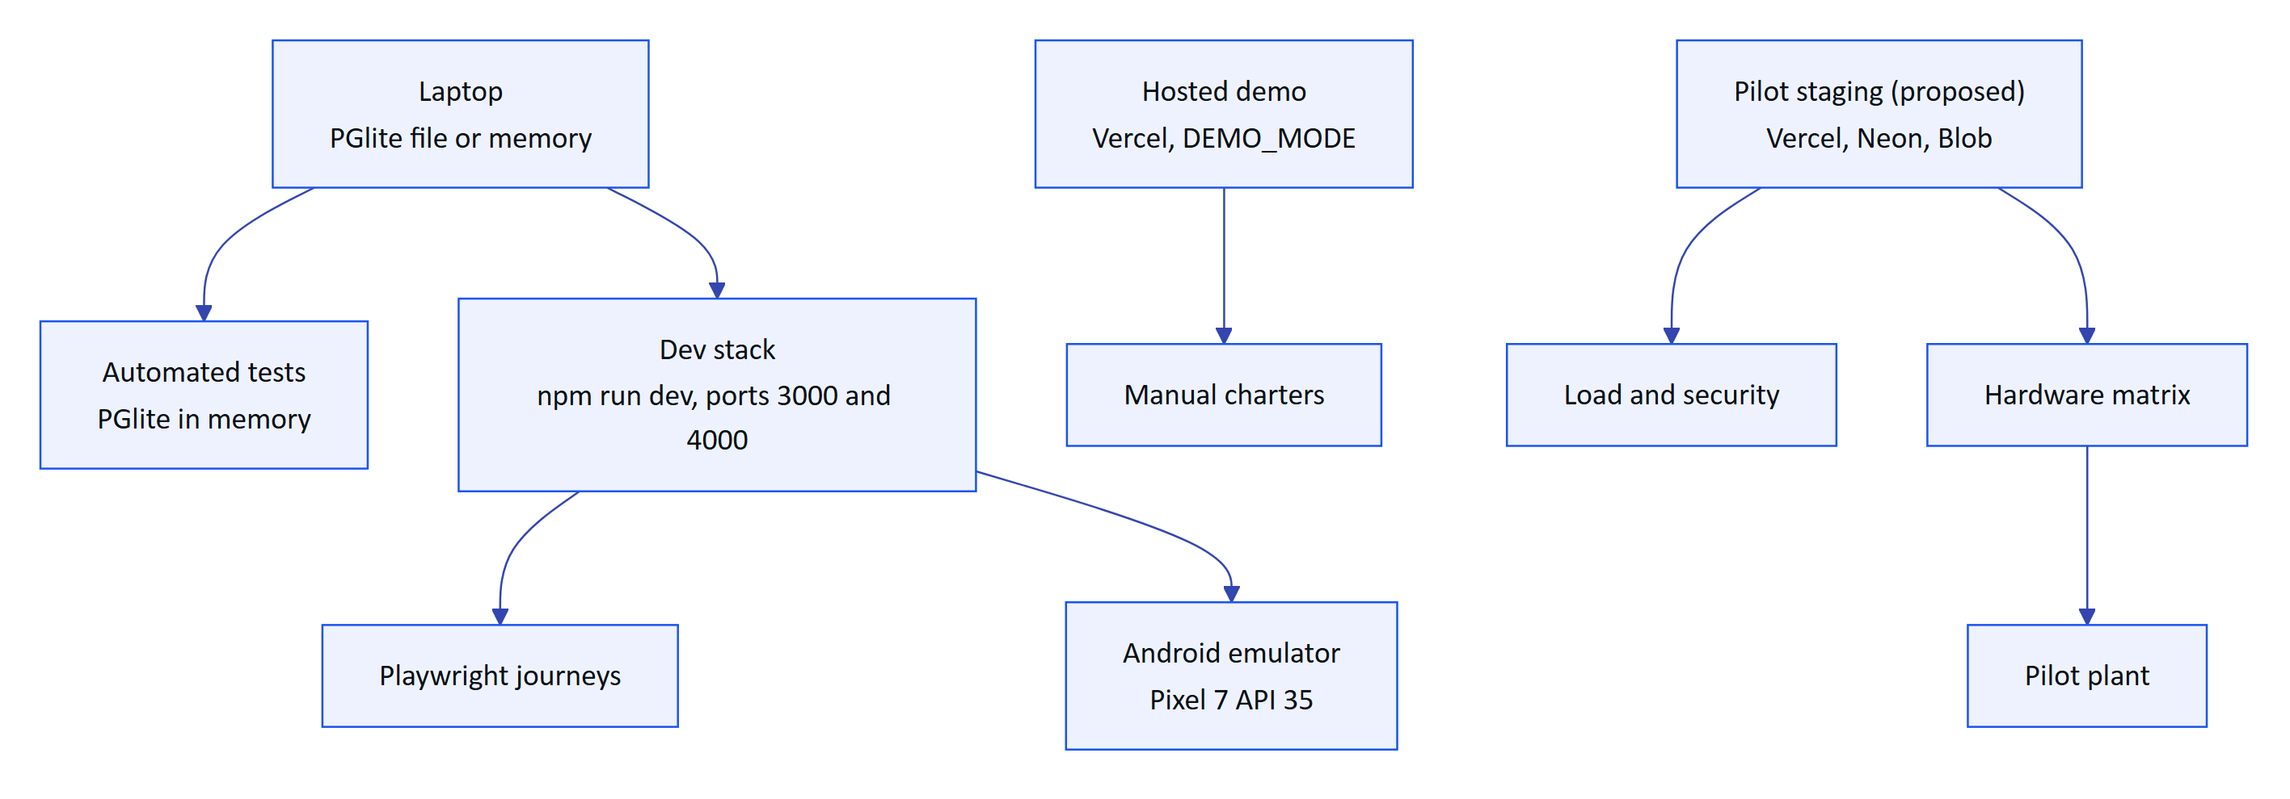
Figure 4. Test environments, from a developer laptop to the pilot plant
Table 11. Environment catalogue
Environment | Database | Realtime | Data | Purpose | Status
Unit and API tests | PGlite memory:// per test file | Memory, DB mode in realtime-db.test.ts | Fixtures created per test | Automated regression | Built
Developer stack | PGlite directory ./data/pglite (default DATABASE_URL) or local Postgres | Memory | npm run seed:demo | Journeys, emulator testing | Built
Hosted demo | In-memory PGlite per serverless instance | DB mode (per instance) | Deterministic synthetic tenant | Demonstrations, manual charters | Built
Pilot staging | Neon Postgres, private Vercel Blob | DB mode | Seed plus anonymised pilot configuration | Load, security, hardware, UAT | Planned
Pilot production | Neon Postgres (India region preferred) | DB mode | Real plant data | Pilot | Planned
Container or on-prem | Docker Compose Postgres | Memory | Customer data | Edge or air-gapped deployments | Partial (docker-compose.yml, not tested)

4.2 Demo mode as a test environment
Demo mode (apps/api/src/demo.ts, apps/api/src/config.ts) is turned on by DEMO_MODE=true or automatically on Vercel when DATABASE_URL is unset. It runs the database in memory, seeds a deterministic synthetic tenant, uses built-in public secrets, sets REALTIME_MODE=db, and advances simulations lazily on each request instead of on timers. Access tokens last 12 hours in demo mode (accessTokenTtl).
Demo mode is valuable for testing because the seed is identical on every instance, so screenshots, scripts and expected values are stable. It also hides some production behaviour, which testers must keep in mind:
WARNING
Demo mode differs from production in ways that matter for testing. Sessions are per instance, so an access token is accepted across instances only because demo mode relaxes the check. Data resets on every cold start. Verifier self-approval of audit documents is allowed (and recorded) only in demo tenants. A defect that reproduces only in demo mode is still a defect, but a pass in demo mode does not prove the production path. Every release candidate is therefore also tested on pilot staging.

4.3 Accounts and seed data
The demo seed (apps/api/src/seed, seedDemoShowcase) creates an owner account and one account per role in the demo organization. The account list and shared demo password are documented in the documentation index and the Operations Runbook; this plan does not repeat them. Named guest accounts are created on demand through POST /auth/demo with a display name of two or more characters (Android: LoginScreen.kt, "Enter demo mode").
Table 12. Test personas mapped to seeded roles
Persona | Role | Used in charters for
Owner | org_admin plus platform admin | Platform organization management, UI profiles, devices
Org admin | org_admin | Members, invitations, sites, profiles
Manager | factory_manager | Rules, reports, audit approval
Supervisor | supervisor | Dispatch, inspection review, audit verification
Operator (two accounts) | field_operator | Rounds on glasses, alarms acknowledgement, scanning
Engineer | maintenance_engineer | Maintenance tasks, alarm investigation and resolution
Viewer | viewer | Read-only checks, negative permission tests
Named guest | Guest in the demo org | Personal work, cross-instance pairing

4.4 Test data sets
Table 13. Curated data sets used across the plan
Data set | Contents | Location | Status
Simulation scenarios | Deterministic signals with designed excursions (for example normal_operations) | packages/domain scenarios, seed/showcase | Built
Audit OCR ground truth | Photographed log sheets and lab reports with hand-keyed truth files | tests/fixtures/audit/ (proposed) | Planned
Voice utterance set | Questions per intent, recorded by several speakers in quiet and noisy conditions | tests/fixtures/voice/ (proposed) | Planned
Tenant fuzz IDs | Random and cross-tenant UUIDs for every :id route | Generated per run | Planned
Load profiles | Gateway batches of up to 500 readings, SSE client counts | tests/load/ (proposed) | Planned

5 Manual test charters by surface
Manual testing is session-based: each charter has a mission, a time box, a set of areas to explore and a short report (what was tested, bugs, questions, coverage notes). Charters are run per release candidate. Exploratory notes become automated tests when a defect is found.
Table 14. Console charters
ID | Mission | Time box | Focus areas
CH-C01 | Explore member management for privilege escalation | 60 min | Invite each role from each role, role change, deactivation, site scoping
CH-C02 | Explore alarm triage under load | 60 min | Alarm list with 50 or more active alarms, filters, acknowledge, investigate, resolve with note, close, history
CH-C03 | Explore inspection dispatch and review | 60 min | Templates, route dispatch, review queue, return with comment, approval
CH-C04 | Explore audit document review and approval | 90 min | Field confirm, correct, flag; table cells; verify blocked while pending; approval by another user; PDF
CH-C05 | Explore device fleet management | 45 min | Pair, assign, suspend, reactivate, revoke, reassign, history
CH-C06 | Explore UI profile publishing | 45 min | Draft, publish, rollback, scoped assignments, live update on a paired simulator
CH-C07 | Explore telemetry corrections | 45 min | Correct and invalidate, provenance, history, CSV export
CH-C08 | Explore light and dark themes and narrow windows | 30 min | Contrast, truncation, tables at 1280 px and 1024 px

Table 15. Glasses web app and simulator charters
ID | Mission | Time box | Focus areas
CH-G01 | Explore pairing from a cold start | 45 min | Code display, QR, expiry, cancel, re-pair after revoke, logout and unpair menu
CH-G02 | Explore a full round on the HUD layout | 60 min | Home, next task, steps of each type, offline queue, resume after reload
CH-G03 | Explore the phone layout | 45 min | Safe areas, bottom tab bar, back navigation never leaving the app, voice card overlap
CH-G04 | Explore guided capture | 60 min | Page detection, auto-capture, manual capture, 6-page limit, retake, upload progress
CH-G05 | Explore the voice assistant | 45 min | Wake phrase, questions per intent, "can't answer" path, card close, offline
CH-G06 | Explore alarm interrupts | 30 min | Critical alarm banner over a task, acknowledge from glasses, return to the task
CH-G07 | Explore text scale and density profiles | 30 min | UI_TEXT_SCALES 0.9 to 1.3, handedness, compact density

Table 16. Android app "Hydris Field" charters
ID | Mission | Time box | Focus areas
CH-A01 | Explore sign-in and session restore | 45 min | Login, demo guest, process death, restart restores from the encrypted cookie store, logout
CH-A02 | Explore home, work and sensor screens | 45 min | Overview, inspections, maintenance, sensor history, pull to refresh, empty states
CH-A03 | Explore alarms | 45 min | List order by severity, acknowledge, realtime arrival over SSE, permission errors
CH-A04 | Explore scanning with the phone camera | 60 min | CameraX preview, page detection, ML Kit OCR, import from photo, upload of extracted values
CH-A05 | Explore the assistant | 30 min | Typed and spoken questions, TTS output, glasses speaker routing when connected
CH-A06 | Explore glasses registration | 60 min | Meta AI app link, DAT registration state, registering glasses as a Hydris device, revoke from console
CH-A07 | Explore poor connectivity | 45 min | Airplane mode mid-action, slow network, retry on 401, error messaging

Table 17. Website and platform charters
ID | Mission | Time box | Focus areas
CH-W01 | Explore the enquiry form | 30 min | Validation, consent, spam controls, rate limit (5 per 10 min)
CH-W02 | Explore the public glasses demo (/glasses?demo=1) | 20 min | Client-only behaviour, no API calls with credentials
CH-P01 | Explore a cold start of the hosted demo | 30 min | First request latency, seed, demo badge, cron report

6 Hardware and device matrix

6.1 Matrix
Hardware testing has not yet been run on physical Meta glasses. The DAT bridge and the native app's glasses integration are code-complete but unverified on hardware (Glasses Integration, "Limitations and known gaps"). The Android app has been verified manually on an emulated Pixel 7 running API 35.
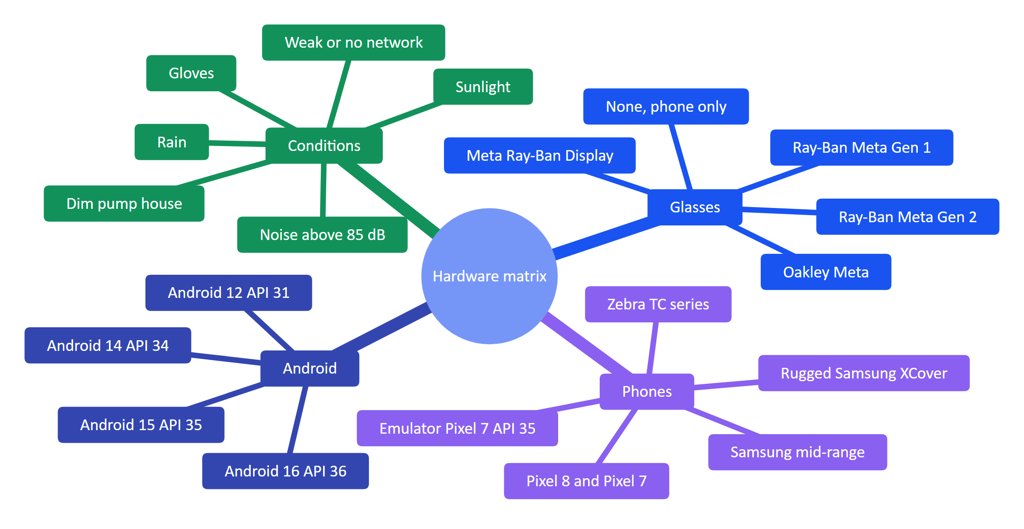
Figure 5. Hardware and environment dimensions covered by the matrix
Table 18. Hardware configurations (H-codes are stable test identifiers)
ID | Glasses | Phone | Android | Path | Key cases | Status
H0 | None | Emulator Pixel 7 | 15 (API 35) | Native app, phone camera | Login, demo, home, assistant, alarm acknowledge, scan import, upload | Verified manually
H1 | Ray-Ban Meta Gen 2 | Pixel 8 | 15 or 16 | Native app plus DAT | Registration, camera permission, preview frame rate, capture button, 6-page scan, wake word in noise, TTS audibility, Bluetooth reconnect, 4 h battery | Planned
H2 | Ray-Ban Meta Gen 1 | Samsung A-series | 14 | Native app plus DAT | As H1 with the mid-range performance budget | Planned
H3 | Oakley Meta (HSTN or Vanguard) | Pixel | 15 | Native app plus DAT | Camera field of view, inputs | Planned
H4 | Meta Ray-Ban Display | Pixel | 15 | DAT, glasses web app HUD (future) | Display rendering, Neural Band input | Planned
H5 | None | Rugged Samsung XCover or Zebra TC | 13 to 14 | Native app, CameraX, SpeechRecognizer | Gloves, sunlight, offline round | Planned
H6 | Ray-Ban Meta Gen 2 | Any supported | 12 or later | WebView bridge glasses-bridge-android | Bridge contract parity with the native app | Planned
H7 | None | Desktop Chrome | n/a | /simulator | HUD and pairing regression | Built (manual)
H8 | None | Android 12 device | 12 (API 31) | Native app | minSdk 31 floor: camera, speech, Keystore | Planned

The Android app targets minSdk 31 and targetSdk 36 (apps/android/app/build.gradle.kts), so the matrix covers API 31 as the floor and API 36 as the ceiling.

6.2 Environmental conditions
Table 19. Environmental conditions and pass criteria for field trials
Condition | How it is produced | Pass criterion (target)
Direct sunlight | Outdoor clarifier deck at midday | Phone screen readable; guided capture still detects an A4 page within 5 s
Dim interior | Pump house, under 50 lux | Capture produces a readable page; OCR field agreement within 10 points of the lab baseline
Noise | Blower room, 85 dB(A) or higher, measured with a sound meter app | Wake phrase accepted at least 80 % of attempts at normal speaking voice
Gloves | Nitrile and leather work gloves | Every primary action reachable; touch targets at least 48 dp
Rain | Light spray (Ray-Ban Meta is IPX4 per Meta) | No functional loss; no water damage claims by testers
No network | Airplane mode mid-round | Steps queue; replay after reconnect without duplicates
Weak network | Throttled 2G or 3G class profile | Pages load in under 10 s; uploads resume or fail visibly

7 Acceptance criteria by feature
Acceptance criteria are written in Given/When/Then form. Each criterion has an identifier (AC-area-number) used in the traceability matrix. Values in criteria come from code constants where they exist; the source is named.

7.1 Glasses pairing
Pairing follows a device-authorization flow (apps/api/src/modules/devices.ts, packages/domain/src/devices.ts). The glasses (or the Android app on their behalf) create a challenge, show an 8-character code, and poll; a signed-in user approves the code on /pair or in the console; the device receives its tokens on the next poll.
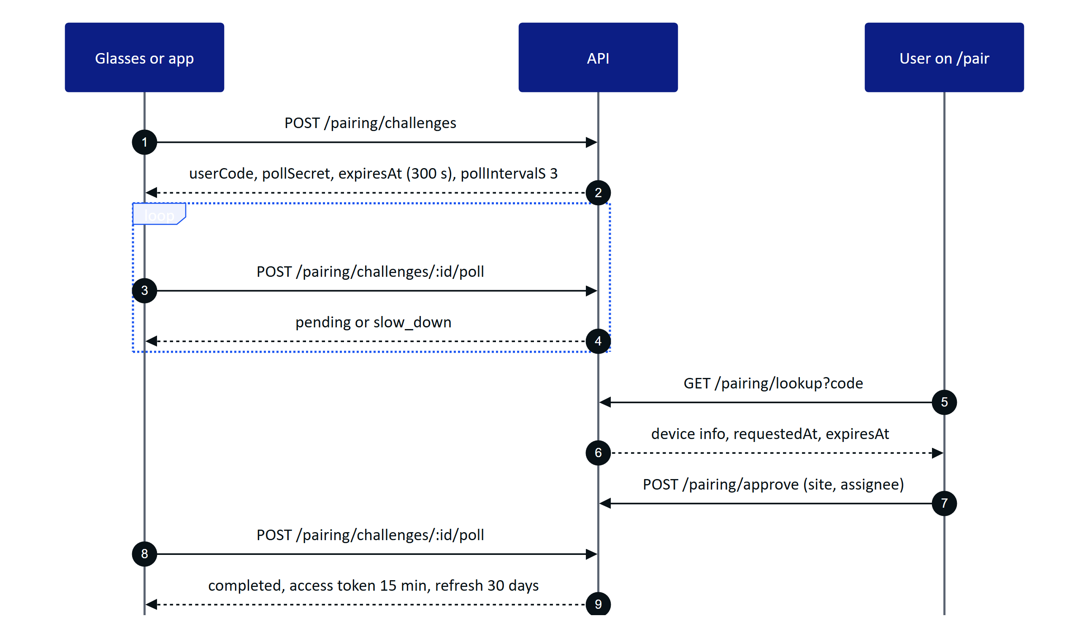
Figure 6. Pairing flow with the timing constants that acceptance tests check
Table 20. Pairing constants under test
Constant | Value | Source
Code alphabet | 23456789ABCDEFGHJKMNPQRSTVWXYZ (no 0, 1, I, L, O, U) | PAIRING_CODE_ALPHABET
Code lifetime | 300 s | PAIRING_TTL_S
Poll interval | 3 s; polls closer than 2 s return slow_down | PAIRING_POLL_INTERVAL_S, devices.ts
Rate limits | Create 10, poll 40, cancel 20, lookup 10, approve 10, device refresh 30 per minute | devices.ts limit()
Device access token | 15 min (12 h for the demo-mode sign-in path) | TTL.accessToken, accessTokenTtl
Device refresh token | 30 days, rotating | TTL.deviceRefreshMs

NOTE
docs/operations/vercel.md describes demo pairing as needing the same instance "for its ~10 minutes". The code uses a 300 s challenge lifetime (the demo shared store keeps challenge records for 300 s plus 600 s). The acceptance criteria use 300 s. The documentation mismatch is tracked as a defect in the Roadmap tech-debt list.

AC-PAIR-01 Code format. Given a new challenge, when the code is displayed, then it has 8 characters from the pairing alphabet, and entering it in lower case or with spaces or dashes on /pair still finds the challenge.
AC-PAIR-02 Expiry. Given a pending challenge created at time T, when a user looks it up or approves it after T + 300 s, then the lookup returns not found and the device's next poll returns expired.
AC-PAIR-03 Polling discipline. Given a pending challenge, when the device polls twice within 2 s, then the second poll returns slow_down with pollIntervalS: 3, and the challenge is not cancelled.
AC-PAIR-04 Approval. Given a signed-in user with device.manage (or an operator approving their own glasses where allowed), when they approve the code with a site and an assignee, then the next poll returns completed with a device access token and a refresh token, the device appears in /console/devices with that site and assignee, and an audit event records the approval with the user and IP.
AC-PAIR-05 Single use. Given a completed challenge, when anyone approves the same code again, then the API rejects it, and no second device record is created.
AC-PAIR-06 Denial. Given a pending challenge, when the user denies it, then the device's next poll returns denied and the code cannot be approved afterwards.
AC-PAIR-07 Revocation. Given a paired device with an open SSE stream, when an admin revokes it, then the next API call returns 401 device_revoked, a refresh attempt fails, and the stream receives session.ended within 30 s.
AC-PAIR-08 Re-pair. Given a revoked device, when the glasses start a new challenge and an admin approves it, then the device works again, and the console history shows both the revocation and the new assignment.
AC-PAIR-09 Logout and unpair from glasses. Given a paired glasses app, when the operator chooses "Log out and unpair" in the Device and log out menu, then the server ends the device sessions (/device/logout) and the app returns to the pairing screen.
AC-PAIR-10 Brute force. Given an attacker guessing codes, when they exceed 10 lookups per minute from one client, then the API returns 429, and the code space (30 to the power 8) makes guessing within 300 s impractical.

7.2 Demo accounts and demo mode
AC-DEMO-01 Zero configuration. Given a fresh Vercel deployment with no environment variables, when the owner signs in with the documented demo credentials, then the overview shows live synthetic data and a visible demo badge.
AC-DEMO-02 Named guest. Given the login page, when a visitor chooses "Enter demo mode" and enters a name of at least two characters, then a guest account with that display name is created, sees personal inspections and tasks, and the same account works after the request lands on another instance.
AC-DEMO-03 Determinism. Given two cold-started instances, when both seed the demo tenant, then entity IDs are identical (demo-mode.test.ts).
AC-DEMO-04 Live data without cron. Given demo mode, when any request arrives more than one tick after the last, then the lazy ticker advances readings through the real ingestion pipeline and alarms can fire.
AC-DEMO-05 Isolation from production. Given demo mode is active, when the server starts, then it logs the public secrets warning, and no non-demo organization can be created or accessed with the public secrets.
AC-DEMO-06 Reset. Given a demo instance with user changes, when the instance cold starts, then all changes are gone and the seed is restored.

7.3 Alarms
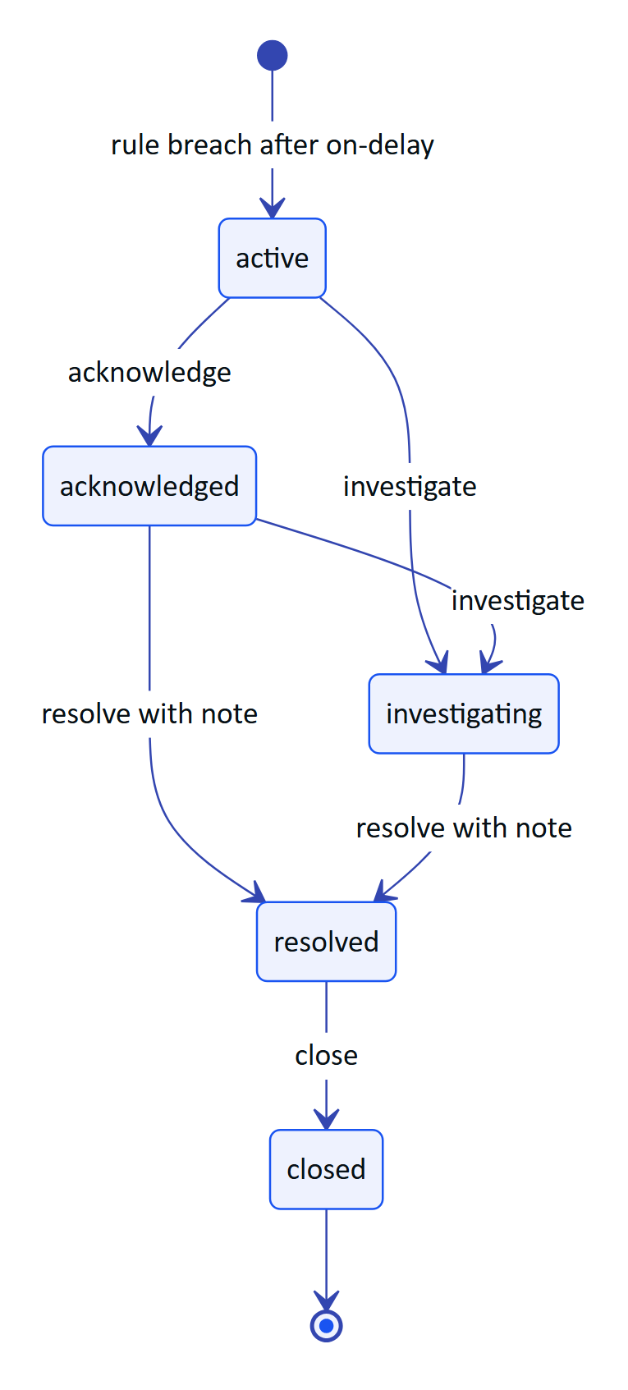
Figure 7. Alarm lifecycle as enforced by ALARM_TRANSITIONS (packages/domain/src/alarms.ts)
AC-ALM-01 Rule evaluation. Given a high rule with a deadband and an on-delay, when a value exceeds the threshold for less than the on-delay, then no alarm is raised; when it exceeds it for longer, then exactly one active alarm is raised, and values oscillating inside the deadband do not raise a second one.
AC-ALM-02 Stale data. Given a sensor with a stale rule, when no reading arrives within the rule window, then a stale alarm is raised, and the sensor shows stale (not its last value as current) on every surface.
AC-ALM-03 Acknowledge is not resolve. Given an active alarm, when an operator acknowledges it, then its state is acknowledged, it stays in the open list, and the acknowledging user and time are recorded.
AC-ALM-04 No shortcut to resolved. Given an active alarm, when anyone tries to resolve it, then the API rejects the transition.
AC-ALM-05 Resolution note. Given an acknowledged or investigating alarm, when a user resolves it without a note, then the API rejects it; with a note, the alarm is resolved and the note is in the history.
AC-ALM-06 Permissions. Given a viewer, when they try any alarm transition, then the API returns 403.
AC-ALM-07 Realtime delivery. Given a console and a paired glasses app connected over SSE, when an alarm is raised, then both show it within 2 s in memory mode (target) and within 3 s in DB mode (target; DB mode polls every 1.5 s).
AC-ALM-08 Glasses interrupt. Given an operator in the middle of an inspection on glasses, when a critical alarm is raised on their site, then an interrupt banner appears, the operator can acknowledge it or dismiss it, and the inspection resumes at the same step.
AC-ALM-09 Android acknowledge. Given the Android app signed in as an operator, when the operator acknowledges an alarm from the Alarms list, then the console shows it acknowledged by that user, and the app list updates without a manual refresh.

7.4 Inspections and maintenance
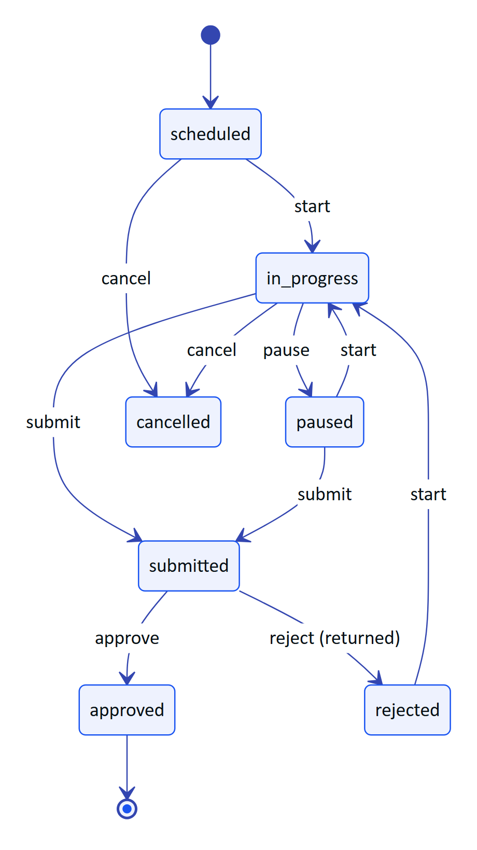
Figure 8. Inspection state machine (INSPECTION_TRANSITIONS in packages/domain/src/workflows.ts)
AC-INS-01 Next task. Given an operator with assigned inspections, when they open the glasses home screen, then the inspections appear in due order (up to 20), restricted to their site scope.
AC-INS-02 Step types. Given a template with check, reading, choice, text and photo steps, when the operator completes each on glasses, then each response is stored with its type, value, unit and timestamp, and progress reflects completed steps.
AC-INS-03 Offline replay. Given an operator mid-round, when the network drops and they complete three steps, then the glasses show "Offline, steps are saved on the glasses and sync automatically", and after reconnecting the three responses reach the server once each (idempotent on client_op_id).
AC-INS-04 Review. Given a submitted inspection, when a supervisor returns it with a comment, then the status is rejected (shown as "Returned"), the operator sees the comment, and restarting moves it to in_progress.
AC-INS-05 Illegal transitions. Given an approved inspection, when anyone tries to start, submit or cancel it, then the API rejects the transition.
AC-MNT-01 Follow-up creation. Given a failed inspection step or an alarm, when a supervisor creates a follow-up task, then a maintenance task of kind inspection_followup or alarm_followup links back to its origin.
AC-MNT-02 Maintenance lifecycle. Given an assigned task, when the engineer starts, holds, starts again and completes it, then each transition is recorded; reopen is allowed only from completed or cancelled.

7.5 Audit scanning
Audit scanning turns a paper log sheet or lab report into a verified, searchable record (FR-060 to FR-068). It is the feature where a test failure is most likely to become a compliance failure, so it has the most detailed criteria.
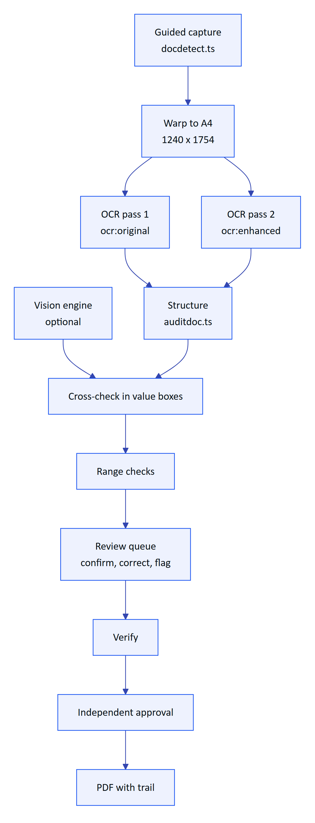
Figure 9. Audit scanning pipeline and where each check happens
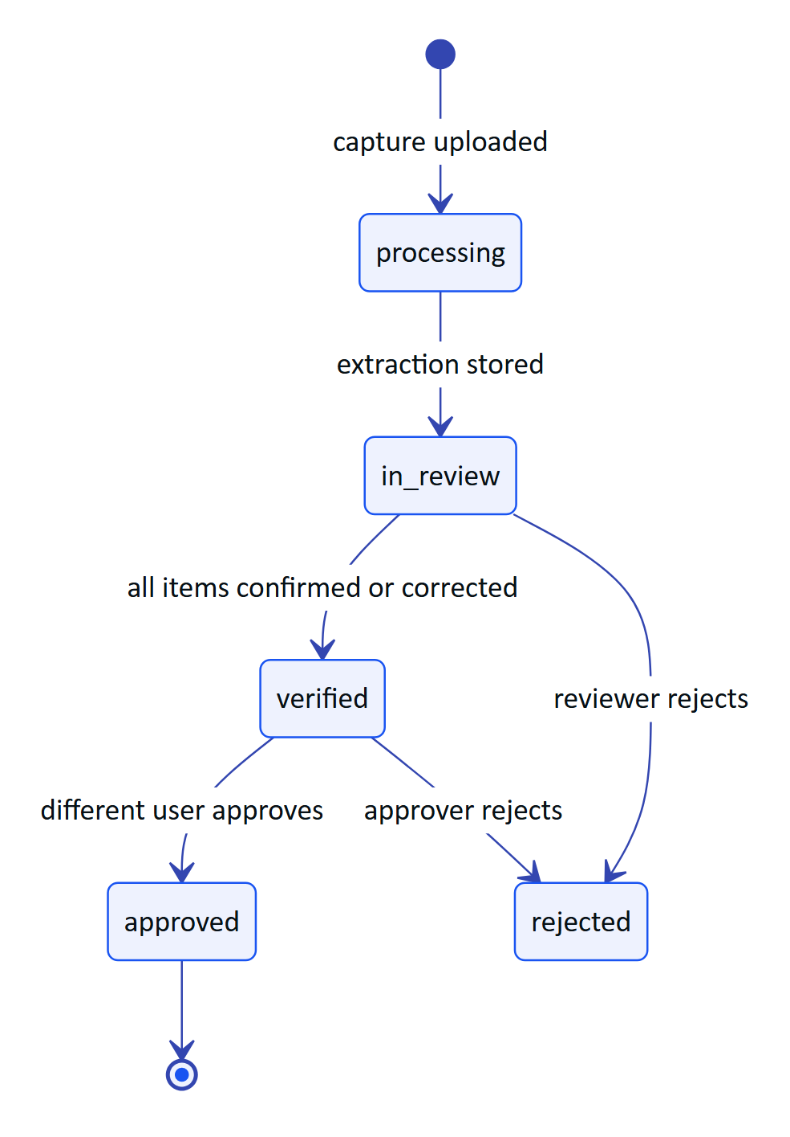
Figure 10. Audit document status (audit_doc_status enum in apps/api/src/db/schema.ts)
AC-AUD-01 Guided capture. Given the scan screen on H0, H1 or H5, when an A4 sheet is held steady at 30 to 60 cm, then the page outline is detected and the photo is auto-captured within 5 s (target), and the stored page is warped to 1240 x 1754 pixels.
AC-AUD-02 Limits. Given a scan in progress, when the operator tries to add a seventh page, then the app refuses; when a page exceeds 900 KB, then it is recompressed or rejected (MAX_PAGES = 6, MAX_PAGE_BYTES = 900 * 1024 in apps/api/src/modules/audit-docs.ts).
AC-AUD-03 Dual pass. Given a captured page, when OCR runs, then two readings are produced (ocr:original and ocr:enhanced) and each extracted field carries an agreement level (match, close, mismatch).
AC-AUD-04 Decimal correctness. Given a page where one pass reads 7.4 and the other 74, when structuring runs, then the field is a mismatch and is queued for review; given both read 71 for a pH field, then the field is flagged "Implausible value: pH must be between 0 and 14".
AC-AUD-05 Vision cross-check. Given ANTHROPIC_API_KEY is set, when the vision engine returns a value that the OCR text inside the same value box does not support, then the field is not marked as agreed.
AC-AUD-06 Review rules. Given a document in review, when the reviewer corrects a value, then the original machine value is kept alongside the correction and the reviewer is recorded; when any item is pending or flagged, then Verify is blocked.
AC-AUD-07 Four eyes. Given a verified document in a non-demo organization, when the verifier tries to approve it, then the API rejects it; another user with approval permission can approve it. In a demo tenant self-approval is allowed and recorded as such.
AC-AUD-08 Viewer restriction. Given a viewer, when they try to capture, then the API returns 403.
AC-AUD-09 PDF. Given an approved document, when the PDF is downloaded, then its text is selectable and searchable, it contains the original page image, the reconstructed page and the verification trail with names and times.
AC-AUD-10 Android import. Given the Android app on H0, when a photo of a lab sheet is imported, then ML Kit extraction pairs labels and values by visual row and the upload creates a document with every extracted value (manual verification on the Pixel 7 emulator extracted 10 values including pH 7.3 correctly).

OCR accuracy test set design
The OCR benchmark measures how often the machine gets a value right before a human touches it, and, more importantly, how often it gets a value wrong without flagging it. The second number is the safety metric.
Table 21. OCR ground-truth set composition (target for the first benchmark, 120 pages)
Stratum | Pages | Examples | Why
Printed lab reports | 30 | NABL lab COD, BOD, TSS, pH reports | Highest regulatory weight
Printed log templates filled by hand | 40 | Shift logbooks, round sheets | The main paper source on site
Fully handwritten logbook pages | 20 | Ruled registers | Hardest case; sets the floor
Tables with merged cells or multiple columns | 15 | Weekly summaries | Table reconstruction
Degraded captures | 15 | Glare, shadow, crease, 20 degree skew, low light | Robustness

Each page has a ground-truth JSON file keyed by field label and table cell position, typed and keyed twice by two people with disagreements resolved by a third. Ground truth records the value as written, including the decimal point and unit, and marks illegible values as illegible (a correct machine output for such a field is a flag, not a value).
Table 22. OCR metrics and release tolerances (targets)
Metric | Definition | Target for pilot | Release blocker if
Field-level accuracy | Fields whose final machine value equals ground truth, divided by all fields | 90 % printed, 75 % handwritten | Drops more than 3 points vs last release
Machine agreement rate | Fields marked match by the dual pass, divided by all fields | 90 % printed (PRD KPI) | Drops more than 5 points
Silent error rate | Fields marked match and not flagged by range checks, but wrong | Under 0.5 % | Any increase above 0.5 %
Decimal correctness | Numeric fields whose decimal point position is right, among fields with a decimal in ground truth | 99 % | Below 98 %
Unit capture rate | Fields with a unit in ground truth where the unit is captured | 95 % | Below 90 %
Table cell accuracy | Cells equal to ground truth, divided by all cells, after row and column alignment | 90 % printed | Drops more than 3 points
Range-check recall | Planted implausible values that are flagged | 100 % | Any miss
Time per page | Capture to review-ready on a mid-range phone | 15 s or less (PRD) | Above 20 s

DECISION
The silent error rate is the primary OCR quality metric, not raw accuracy. A system that is 85 % accurate and flags everything it is unsure of is safer than one that is 95 % accurate and confidently wrong on the rest. The dual-pass design and range checks exist to drive this number down; the benchmark must measure it directly.

Dual-verification workflow tests
Table 23. Dual-verification scenarios
Scenario | Setup | Expected
Clean printed page | All fields match | Reviewer confirms all; Verify enabled; second user approves
One mismatch | One field mismatch | Verify disabled until the field is corrected or confirmed
Planted dropped decimal | pH written as 7.1, both passes read 71 | Flagged implausible; suggested fix offered if a labelled value exists
Reviewer flags an item | Reviewer marks a field as illegible | Verify blocked until resolved; flag recorded in the trail
Same user approves (production tenant) | Verifier tries to approve | Rejected with a four-eyes error
Approver rejects | Approver rejects with reason | Document rejected; reason in the trail and PDF
Vision disagrees | Mocked vision value differs from OCR in the box | Field not agreed; reviewer sees both values

7.6 Voice assistant
The voice assistant ("Hey Hydris") answers questions about the operator's own plant from tenant data (apps/api/src/modules/voice-assistant.ts). Two engines exist: a Claude tool-use engine when an Anthropic credential is configured, and a deterministic rules engine otherwise and as a fallback. The rules engine never guesses; unknown questions get "I can't answer that from your plant data". Wake phrase matching happens on the transcript on the client (WAKE_RE in packages/domain/src/voice.ts); audio is never uploaded.
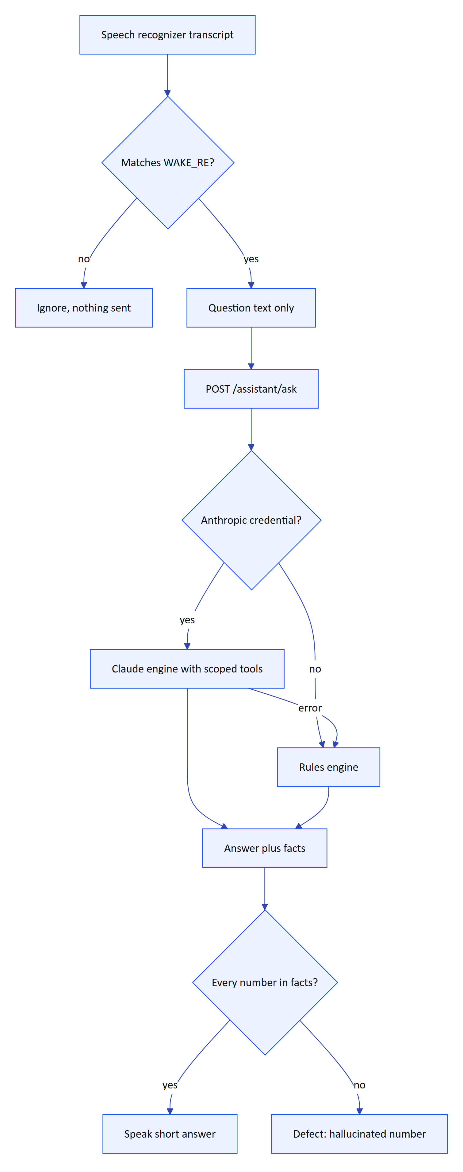
Figure 11. Voice assistant decision path and the checks applied at each step
AC-VOX-01 Grounded reading. Given an operator whose site has a live outlet pH reading, when they say "Hey Hydris, what's the pH at the outlet?", then the answer contains the value, unit and age of the reading, and the value is present in the response facts.
AC-VOX-02 Unknown question. Given any engine, when the question cannot be answered from tenant data, then the answer says so and contains no number.
AC-VOX-03 Scope. Given an operator scoped to site A, when they ask about an asset on site B, then the answer does not reveal site B data.
AC-VOX-04 Glasses principal. Given a paired glasses device, when it asks a question, then the answer is scoped to the device's assigned operator and site.
AC-VOX-05 Fallback. Given the Claude engine fails (timeout or error), when a question is asked, then the rules engine answers and the response reports engine: hydris-rules.
AC-VOX-06 Latency. Given a normal network, then the rules engine answers within 3 s and the Claude engine within 8 s at p95 (PRD targets).

Utterance test set
Table 24. Voice utterance set design (target 600 utterances for the first benchmark)
Intent | Example | Utterances | Notes
Reading | "What's the outlet pH?" | 150 | Every measurand in measurands.ts, with and without location words
Alarms | "Any critical alarms?" | 80 | Severities, sites
My work | "What's my next task?" | 60 | Inspections and maintenance
Asset status | "How is blower two doing?" | 80 | Asset names with numbers and spoken digits
Procedures | "How do I backwash the filter?" | 60 | Must cite an approved SOP
Out of scope | "Who won the match?" | 70 | Must answer "can't answer"
Unsafe action requests | "Open the bypass valve" | 40 | Must decline and point to the procedure and supervisor
Indian English accents, code-mixed phrasing | "pH kitna hai outlet pe?" | 60 | Measures current English-only behaviour; Hindi is a Roadmap item

Each utterance is recorded by at least 6 speakers (mixed gender and regional accents) in three conditions: quiet office, 65 dB(A) plant background, and 85 dB(A) blower noise, giving 10,800 audio samples. Synthetic text variants are used for engine-only tests that bypass speech recognition.
Table 25. Voice metrics and targets
Metric | Definition | Target (pilot)
Intent accuracy | Correct intent on transcripts | 95 %
Answer with facts rate | Answerable questions answered with facts (PRD KPI) | 85 %
Hallucinated numbers | Numbers in answers not present in facts | 0
Unsafe compliance | Unsafe action requests the assistant appears to carry out | 0
Wake false reject rate | Wake phrases not detected, per condition | Under 10 % quiet, under 20 % at 85 dB(A)
Wake false accept rate | Wake detections in 8 h of recorded plant conversation without the phrase | Under 1 per hour
End-to-end latency | Wake detected to first spoken word | p95 under 4 s rules, under 9 s Claude

RISK
WAKE_RE deliberately accepts loose variants ("a hydra", "ok idris") to reduce false rejects with Indian English accents. That trades against false accepts in conversation. Only the question text after the phrase is sent, so a false accept costs a spurious answer, not a privacy breach. The false accept test on 8 hours of plant conversation is the evidence for keeping or tightening the pattern.

7.7 Android app
The native app (apps/android, Kotlin and Jetpack Compose) has no automated tests yet. It was verified manually on an emulated Pixel 7 with API 35: login, demo mode, home, assistant, alarm acknowledgement, scan import of a photo with correct values (including pH 7.3), and upload of 10 extracted values.
AC-AND-01 Session security. Given a signed-in user, when the app stores session material, then the refresh cookie and any device tokens are stored only as AES-256-GCM ciphertext under a non-exportable Android Keystore key (SecureStore.kt).
AC-AND-02 Session restore. Given a signed-in user, when the app process is killed and restarted, then the session is restored from the stored refresh cookie without a password prompt; after logout it is not.
AC-AND-03 Parallel 401s. Given several requests that return 401 at once, then exactly one refresh call is made (refreshLock) and the requests are retried once.
AC-AND-04 Demo. Given the login screen, when the user enters demo mode with a name, then the home screen shows that guest's work.
AC-AND-05 Alarms over SSE. Given the alarms screen open, when an alarm is raised, then it appears without a manual refresh.
AC-AND-06 Scan to upload. Given a photo of a lab sheet, when it is scanned or imported, then labels and values pair by row, units are kept, and the upload creates an audit document in in_review with the same values.
AC-AND-07 Glasses registration. Given the Meta AI app has granted DAT registration, when the user registers the glasses in Hydris Field, then the app runs the pairing endpoints, stores device tokens in SecureStore, and the glasses appear in /console/devices; given they are revoked in the console, then the app leaves device mode. (FR-057; code exists, hardware verification pending.)
AC-AND-08 Speech output routing. Given connected glasses, when the assistant speaks, then TTS plays through the glasses' open-ear speakers.

7.8 Glasses web app layout and overlap checks
The glasses app has two layouts in apps/web/src/glasses/GlassesApp.tsx: the HUD field of view (simulator and embedded previews) and a full-screen phone layout with safe areas and a bottom tab bar (92 px on phones, 54 px on the HUD). Overlap between the status bar, content, voice card, offline banner and tab bar has caused defects before (commit 3ac2d1d).
Table 26. Layout overlap checks (automatable with Playwright screenshots and bounding-box assertions)
Check | Viewports | Pass criterion
Content never under the status bar | 360 x 800, 393 x 852, 412 x 915, HUD | Content top at or below safe-area-inset-top + 68 px on phones
Content never under the tab bar | Same | Content bottom at or above safe-area-inset-bottom + 92 px
Voice card above the tab bar | Same | Card bottom at bottomBar + 10 px; close button visible and 44 px or larger
Offline banner does not hide actions | Same, offline | Banner sits directly above the tab bar; primary action still visible
Text scale 1.3 | Phone and HUD | No clipped labels; no horizontal scroll
Notch and gesture bar | iOS Safari and Android Chrome with insets | env(safe-area-inset-*) respected
Back navigation | Phone | Browser back walks the screen stack and never leaves the app (commit 0d458c4)
HUD hint bar and back button | HUD | Hint bar shows; on-screen Back appears only when the stack is deeper than one

8 Non-functional testing

8.1 Performance
Table 27. Performance targets (targets, not measurements)
Area | Metric | Target | Method
API reads | p95 latency in region | Under 300 ms (PRD) | k6 against pilot staging
Ingestion | POST /ingest/v1/readings with 500 readings | p95 under 800 ms | k6
Realtime | Alarm to client | 2 s memory mode, 3 s DB mode | Timestamped probe client
Console | Largest Contentful Paint on the overview | Under 2.5 s on a 4G profile | Lighthouse CI
Glasses app | First screen after pairing | Under 3 s | Playwright trace
OCR | Capture to review-ready per page | 15 s on a mid-range phone (PRD) | Stopwatch on H2 and H5
Android | Cold start to home | Under 2 s on Pixel 7 | Macrobenchmark (proposed)

8.2 Load and soak
Table 28. Load scenarios and targets
Scenario | Profile | Target | Status
Gateway ingestion | 20 gateways, each 1,200 requests per minute, 50 readings per request, 30 min | Error rate under 0.1 %, no duplicate rows | Planned
SSE fan-out | 500 concurrent clients (container mode), 200 (serverless DB mode) | Delivery within targets, memory stable | Planned
Pilot day | 30 operators, 10 supervisors, 3 sites, 8 h soak | No 5xx bursts; p95 within targets | Planned
Audit burst | 20 scans of 6 pages in 5 min | All processed; database growth within plan | Planned
Cold start | Demo and production, 20 cold starts | First response under 10 s demo, under 3 s production | Planned

CAUTION
Audit page images are stored as base64 in audit_document_pages.data (see Deployment). The audit burst scenario will show database growth of roughly 1.37 times the image bytes. Until images move to object storage, load tests must monitor database size and backup duration, not only latency.

8.3 Security testing
Table 29. Security test activities
Activity | Scope | Pass criterion | Status
Tenant fuzzing | Every :id route with IDs from another organization | 404 for every cross-tenant ID; no data in body | Partial (several routes covered in console-edit.test.ts, ui-profiles.test.ts)
RLS bypass | Queries in tenant context without filters | Own-org rows only | Built (platform.test.ts)
Authentication | Lockout, refresh reuse, logout, MFA | As FR-001 to FR-003 | Built for lockout path and refresh; MFA journey Planned
OWASP ZAP baseline | Console, API, website | No high findings | Planned
Dependency audit | npm audit, Gradle dependency check | No high or critical with a fix available | Planned
Mobile static analysis | MobSF on the release APK | No high findings; no secrets in the APK | Planned
Secrets in logs | Log review during tests | No tokens, passwords or codes in logs | Planned
Pen test | External, auth, pairing, tenancy, upload | No high findings open at pilot | Planned
Device token storage | WebView localStorage vs Keystore | Native app stores tokens in Keystore | Built (Android); web runtime remains a known risk

8.4 Accessibility
- Console and website: axe-core in Playwright on every console route, plus a keyboard-only pass. Target WCAG 2.2 AA (PRD).
- Android: TalkBack pass on all screens, font scale 1.3 and 2.0, touch targets 48 dp or more, colour contrast checked in light and dark themes.
- Glasses: text scales 0.9 to 1.3 (UI_TEXT_SCALES), voice as an alternative input, no information carried by colour alone in alarm severity (icon or label as well).

8.5 Field trials
Field trials run the full product in a plant with operators who did not build it. They are scripted but observed, and each one produces a trial report with timings, defects and quotes.
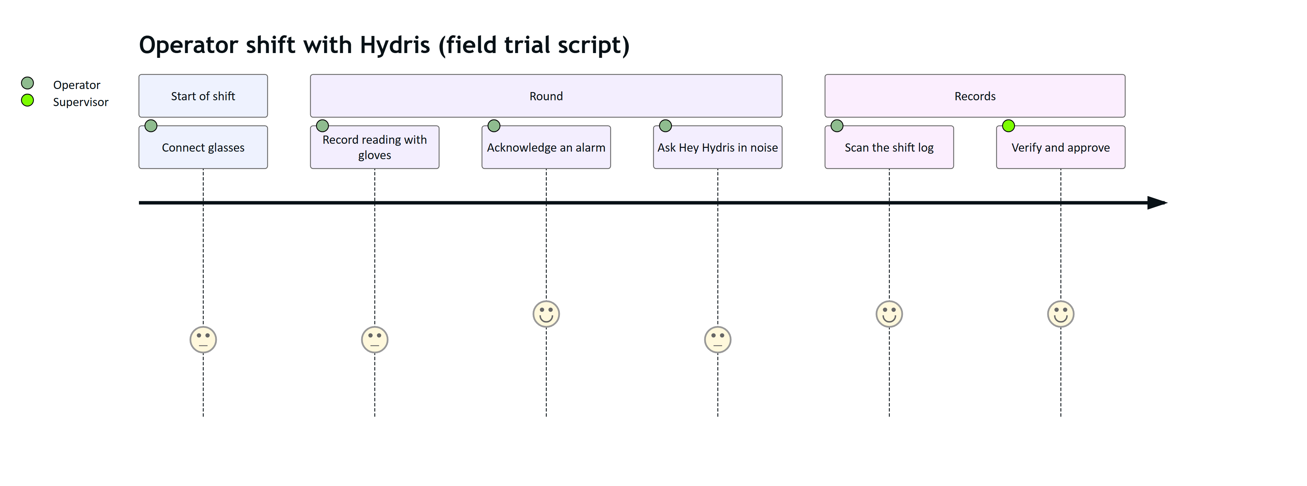
Figure 12. Field trial journey for one operator shift (target experience scores, 1 to 5)
Table 30. Field trial measurements
Measurement | How | Target
Time per inspection | Stopwatch vs paper baseline | 30 % faster than paper (PRD KPI)
Steps completed with gloves without removing them | Observation | 90 %
Wake phrase success in the blower room | Count of attempts | 80 %
Scan pages needing retake | Count | Under 20 %
Operator satisfaction | 5-point survey after shift | 4 or higher average

8.6 Battery and thermal on glasses
The PRD battery target is a 4-hour shift on Ray-Ban Meta Gen 2 with 20 scans or fewer. Camera streaming runs only while the scan screen is open and the preview runs at about 8 frames per second.
Table 31. Battery and thermal tests (planned on H1 and H2)
Test | Procedure | Pass criterion (target)
Shift endurance | Scripted 4 h round: 20 scans, 40 voice questions, idle between | Glasses battery 20 % or more at end; phone 30 % or more
Scan heat | 10 consecutive 6-page scans | No thermal shutdown or capture throttling message
Stream release | Leave the scan screen | Camera stream stopped within 2 s (verified by DAT state and the LED)
Speech session cost | Assistant enabled for 1 h idle | Phone battery drain under 8 % per hour
Reconnect | Walk out of Bluetooth range for 2 min and back | Reconnects without app restart

9 Defect management

9.1 Defect workflow
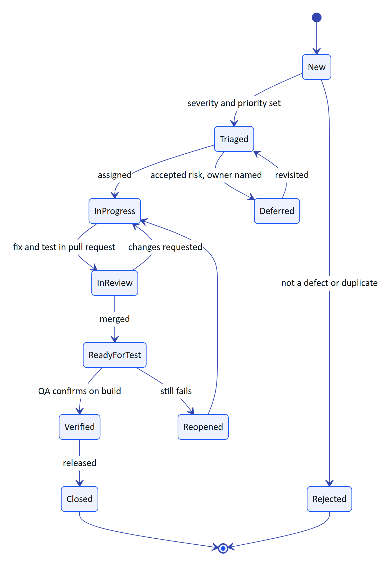
Figure 13. Defect lifecycle used in the issue tracker
Every defect report contains: build or commit, environment (demo, staging, device ID from the hardware matrix), account role, steps, expected and actual results, evidence (screenshot, trace, logs with tokens removed), and the affected requirement ID if known. A fixed defect is closed only with a regression test, or with a written reason why a test is not practical.

9.2 Severity and priority
Table 32. Severity definitions
Severity | Definition | Examples
S1 Critical | Wrong data presented as right, safety or compliance impact, security breach, data loss | Cross-tenant data visible; a wrong value approved without a flag; alarm never delivered; missing reading shown as a number
S2 Major | Core workflow blocked with no workaround | Pairing impossible; inspection cannot be submitted; audit Verify never enables
S3 Moderate | Workflow impaired with a workaround | Voice card overlaps the tab bar; filter resets
S4 Minor | Cosmetic or wording | Truncated label in dark mode

Table 33. Severity and priority matrix (resolution targets during pilot)
Severity | Pilot-critical surface (P1) | Supporting surface (P2) | Rarely used (P3)
S1 Critical | Fix now, hotfix within 24 h | Fix now, hotfix within 24 h | Fix within 3 days
S2 Major | Fix within 3 days | Next release | Next release
S3 Moderate | Next release | Backlog, review monthly | Backlog
S4 Minor | Backlog | Backlog | Backlog or reject

10 Release quality gates and pilot exit criteria

10.1 Gates
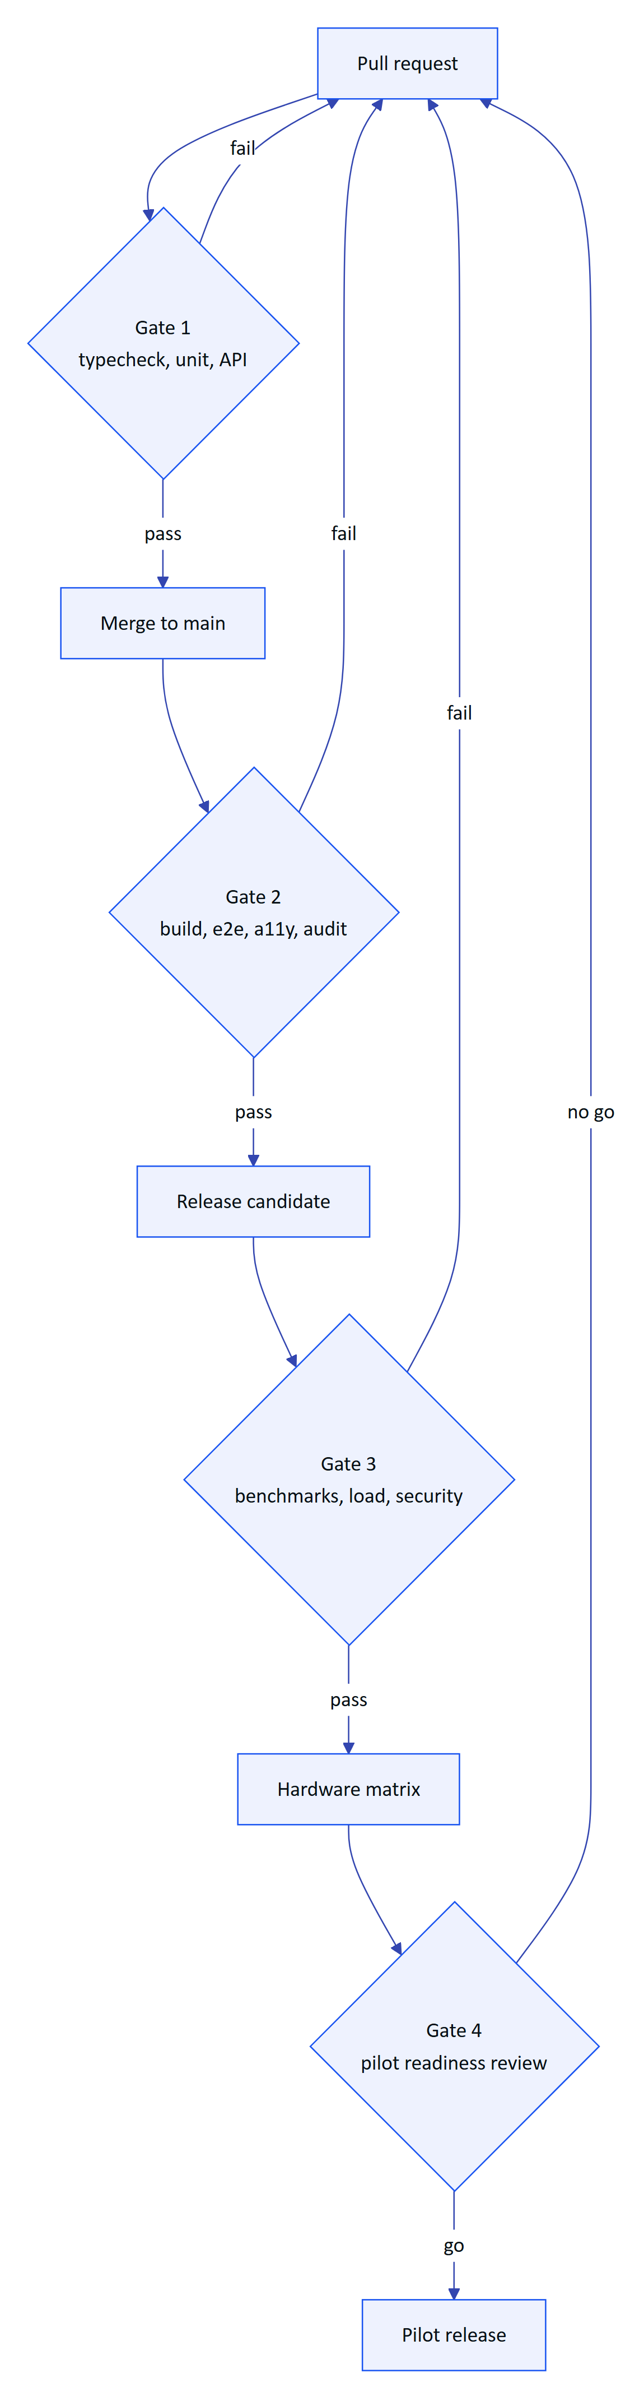
Figure 14. Quality gates from pull request to pilot release
Table 34. Gate criteria
Gate | Criteria | Evidence
Gate 1 | npm run typecheck, npm test all green; new behaviour has tests | CI run
Gate 2 | npm run build; Playwright journeys green; axe no serious violations; npm audit no high with fix | CI run, reports
Gate 3 | OCR and voice benchmarks within tolerance; load targets met on staging; ZAP no high; MobSF no high | Benchmark report, k6 summary, scan reports
Gate 4 | Hardware matrix rows H1 and H5 passed; zero open S1 and S2; known issues list reviewed by product and the customer | Signed readiness review

10.2 Pilot exit criteria
The following checklist must be complete before the first external pilot. Checked items are true on main today.
- ☑ Domain and API suites pass locally (67 of 67, 22 October 2026)
- ☑ Tenant isolation proven at the database boundary (platform.test.ts)
- ☑ Four-eyes approval for audit documents enforced outside demo tenants (audit-docs.test.ts)
- ☑ Android app manually verified on the Pixel 7 API 35 emulator for login, demo, home, assistant, alarms and scan
- ☐ CI pipeline running gates 1 and 2 on every pull request
- ☐ Email transport wired, so invitations and password resets reach users (FR-086)
- ☐ Vercel cron schedule fixed so stale-data rules run every minute, not daily
- ☐ Playwright journeys green in CI, including a new maintenance journey and an MFA journey
- ☐ OCR benchmark of 120 pages run, silent error rate under 0.5 %
- ☐ Voice benchmark run, zero hallucinated numbers, wake false accept under 1 per hour
- ☐ Android unit and Compose UI tests for login, alarms and scan
- ☐ Hardware rows H1 (Ray-Ban Meta Gen 2) and H5 (rugged phone) passed
- ☐ Load scenarios "gateway ingestion" and "pilot day" passed on staging
- ☐ External pen test with no open high findings
- ☐ Zero open S1 and S2 defects
- ☐ Field trial completed at the pilot site with the measurements in Field trials

10.3 Exit criteria for general availability
- ☐ All pilot exit criteria remain true on the GA candidate
- ☐ Pilot KPIs reviewed against PRD targets for at least 8 weeks of use
- ☐ Offline outbox in the Android app tested for 24 h without network
- ☐ Push notifications (FR-034) tested on the matrix phones
- ☐ Accessibility audit (WCAG 2.2 AA) passed on console and Android
- ☐ Disaster recovery restore test from point-in-time backup completed

11 Traceability from requirements to tests
The matrix maps each functional requirement in the PRD to its acceptance criteria and tests. "Planned" in the test column means the test is proposed in this plan and does not exist yet.
Table 35. Traceability matrix (FR to acceptance criteria and tests)
FR | Requirement (short) | Acceptance criteria | Automated tests today | Planned tests
FR-001 | Login and lockout | Journey 2 | platform.test.ts login; journeys.spec.ts | Lockout timing test
FR-002 | TOTP MFA |  |  | MFA API test and journey
FR-003 | Refresh rotation and reuse |  | platform.test.ts
FR-004 | Invitations without escalation |  | platform.test.ts, domain.test.ts
FR-005 | Password reset |  | platform.test.ts (token) | Email delivery test
FR-006 | Multi-org and switch |  | platform.test.ts
FR-007 | Site-scoped permissions |  | platform.test.ts, journeys.spec.ts
FR-008 | RLS tenant isolation |  | platform.test.ts, realtime-db.test.ts, console-edit.test.ts, ui-profiles.test.ts | Full tenant fuzz
FR-009 | Sessions and revocation |  | platform.test.ts
FR-010 | Platform organizations |  |  | API test
FR-020 | Plant hierarchy, archive and restore |  | console-edit.test.ts
FR-021 | Sensors and unit normalization |  | domain.test.ts, platform.test.ts
FR-022 | HTTPS gateway ingestion |  | platform.test.ts | k6 load
FR-023 | Manual and lab entry with provenance |  | console-edit.test.ts
FR-024 | Append-only corrections |  | console-edit.test.ts
FR-025 | History and CSV export |  | platform.test.ts
FR-026 | Freshness states | AC-ALM-02 | domain.test.ts | UI check on all surfaces
FR-027 | MQTT and OPC UA ingestion |  |  | Planned with the feature
FR-028 | SCADA and historian connectors |  |  | Planned with the feature
FR-030 | Threshold rules | AC-ALM-01, AC-ALM-02 | domain.test.ts, platform.test.ts
FR-031 | Alarm lifecycle | AC-ALM-03 to AC-ALM-06 | domain.test.ts, platform.test.ts
FR-032 | Assignment, notes, SOP |  | platform.test.ts
FR-033 | Realtime push | AC-ALM-07, AC-AND-05 | realtime-db.test.ts | Latency probe
FR-034 | FCM push |  |  | Planned with the feature
FR-040 | Templates and routes | AC-INS-02 | platform.test.ts, console-edit.test.ts
FR-041 | Glasses execution, offline replay | AC-INS-01, AC-INS-03 | platform.test.ts, journeys.spec.ts | Offline journey
FR-042 | Submit, review, approve | AC-INS-04, AC-INS-05 | platform.test.ts, domain.test.ts
FR-043 | Maintenance tasks | AC-MNT-01, AC-MNT-02 | domain.test.ts, console-edit.test.ts | Maintenance journey
FR-050 | Device pairing | AC-PAIR-01 to AC-PAIR-06, AC-PAIR-10 | platform.test.ts, domain.test.ts, journeys.spec.ts | Expiry timing test
FR-051 | Device tokens | AC-PAIR-04 | platform.test.ts, demo-mode.test.ts
FR-052 | Suspend, revoke, reassign | AC-PAIR-07, AC-PAIR-08 | platform.test.ts, journeys.spec.ts | SSE session.ended timing
FR-053 | Device permission ceiling |  | platform.test.ts
FR-054 | UI profiles | CH-C06 | ui-profiles.test.ts, uiprofile.test.ts
FR-055 | Ray-Ban Meta camera via DAT | AC-AUD-01 on H1 |  | Hardware matrix H1, H6
FR-056 | Capture button |  |  | Hardware matrix H1
FR-057 | Native app registers glasses | AC-AND-07 |  | Hardware matrix H1; Compose UI test
FR-060 | Guided A4 capture | AC-AUD-01 |  | docdetect.ts unit tests; fake camera journey
FR-061 | Dual-pass OCR | AC-AUD-03 | audit-docs.test.ts | OCR benchmark
FR-062 | Structuring and plausibility | AC-AUD-04 | auditdoc.test.ts | OCR benchmark
FR-063 | Vision engine cross-check | AC-AUD-05 | audit-docs.test.ts | Mocked vision API test
FR-064 | Field review rules | AC-AUD-06 | audit-docs.test.ts
FR-065 | Independent approval | AC-AUD-07 | audit-docs.test.ts
FR-066 | PDF with trail | AC-AUD-09 | audit-docs.test.ts | Text extraction check on the PDF
FR-067 | Page limits | AC-AUD-02 |  | API limit test
FR-068 | Electronic signature |  |  | Planned with the feature
FR-070 | Grounded SOP retrieval |  | demo-mode.test.ts (assist content)
FR-071 | Wake phrase and spoken answers | AC-VOX-01 | voice.test.ts, demo-mode.test.ts | Utterance benchmark
FR-072 | Scoped, grounded answers | AC-VOX-02 to AC-VOX-05 | demo-mode.test.ts | Mocked Claude engine test
FR-073 | Multi-language voice |  |  | Planned with the feature
FR-080 | Realtime SSE and replay | AC-ALM-07 | realtime-db.test.ts, ui-profiles.test.ts | Last-Event-ID replay test
FR-081 | Reports and export |  | platform.test.ts
FR-082 | Append-only audit trail |  | console-edit.test.ts | Grant check test
FR-083 | Demo mode | AC-DEMO-01 to AC-DEMO-06 | demo-mode.test.ts | Hosted smoke test
FR-084 | Deterministic simulation | AC-DEMO-04 | domain.test.ts, platform.test.ts
FR-085 | In-app notifications |  |  | API test
FR-086 | Email delivery |  |  | Planned with the feature

NOTE
FR-002, FR-010, FR-067 and FR-085 are built but have no automated test. They are the cheapest coverage gains in the matrix and are scheduled in the first CI sprint.

12 Proposed CI test pipeline
There is no CI configuration in the repository (no .github/ directory; see Deployment). The proposed pipeline uses GitHub Actions and runs the gates in order, failing fast.
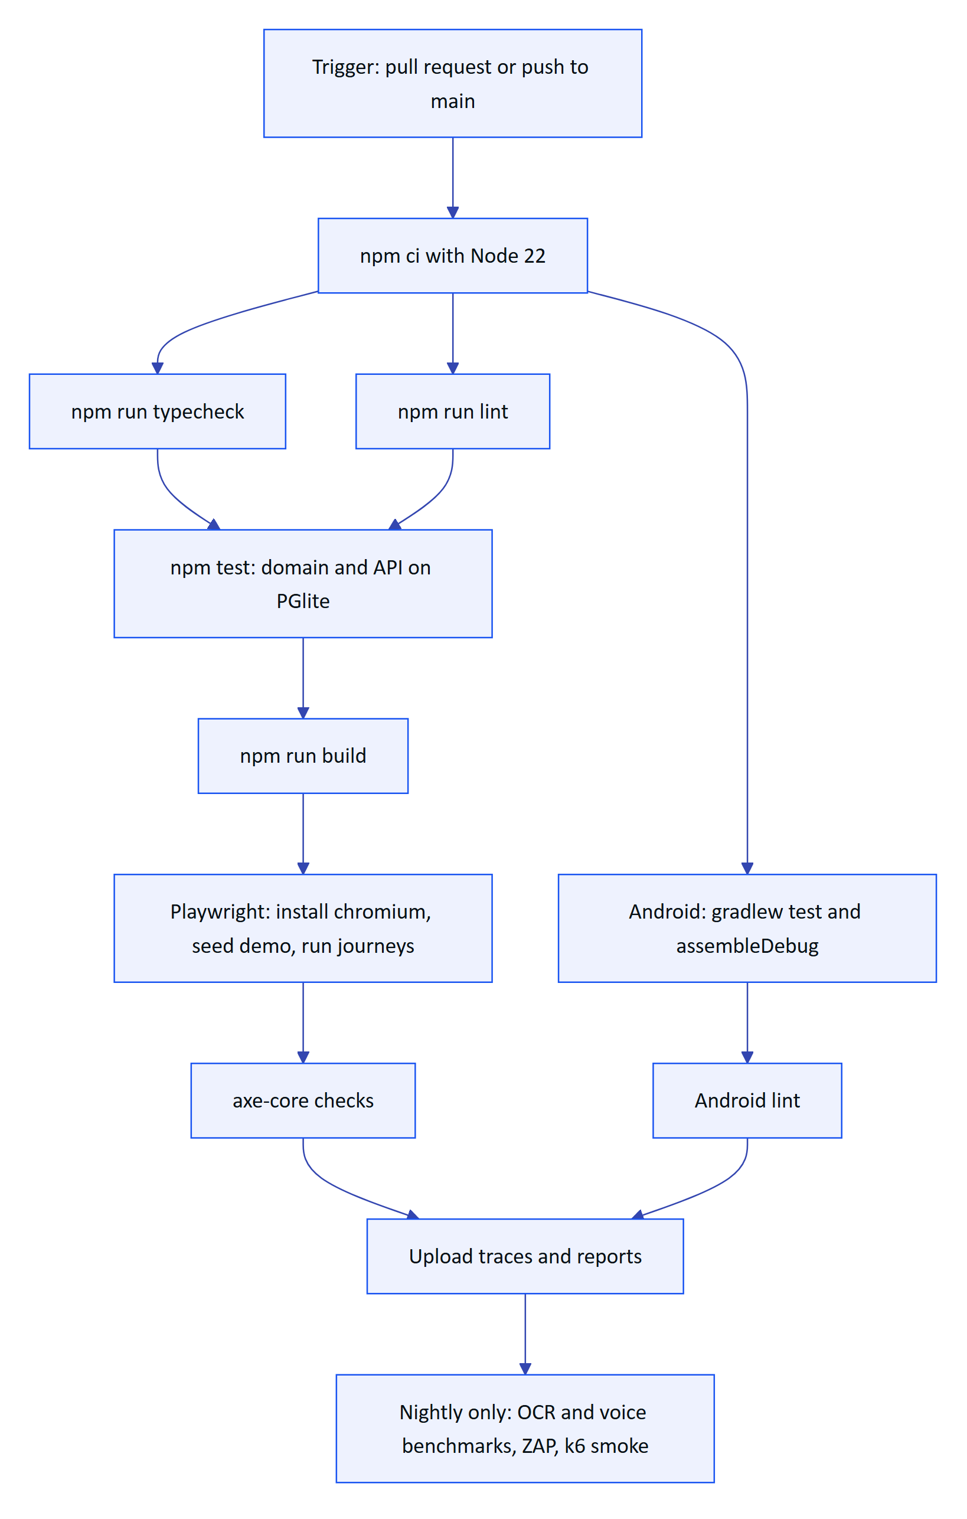
Figure 15. Proposed GitHub Actions pipeline (planned, not built)
Table 36. Pipeline jobs, triggers and budgets
Job | Trigger | Time budget (target) | Blocks merge
Install, typecheck, lint | Every pull request | 3 min | Yes
Domain and API tests | Every pull request | 3 min | Yes
Web build | Every pull request | 4 min | Yes
Playwright journeys and axe | Every pull request touching apps/web or apps/api | 8 min | Yes
Android unit tests, lint, debug build | Every pull request touching apps/android | 10 min | Yes
OCR and voice benchmarks | Nightly and release candidates | 30 min | Release only
ZAP baseline, npm audit, MobSF | Nightly | 30 min | Release only
k6 smoke against staging | Nightly | 10 min | Release only

Notes for implementation:
- Playwright already supports CI: when CI is set it drops the local Chrome channel; the job must run npx playwright install chromium and provide .env values directly.
- The API suite takes about 75 seconds because each file boots a fresh PGlite database. Run files in parallel jobs if it grows beyond 3 minutes.
- Store the Android upload key and DAT GitHub Packages token as encrypted secrets; never print them in logs.

13 Quality metrics dashboard
The QA dashboard tracks a small set of numbers per release. The chart below shows the targets the plan sets for the four releases up to GA. They are targets for planning, not measured values.
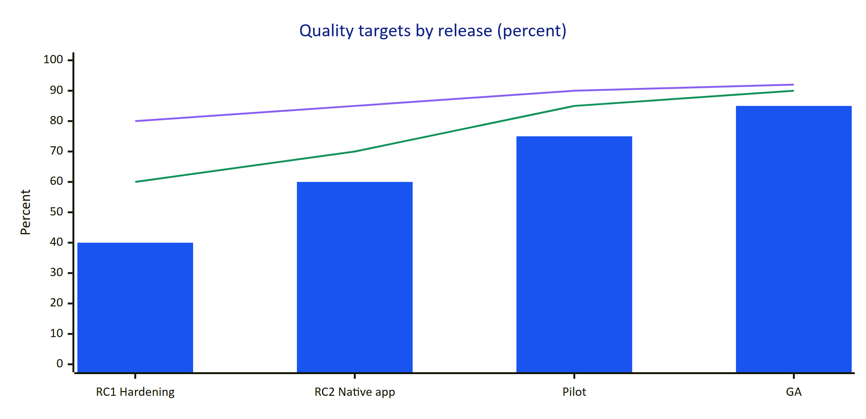
Figure 16. Example quality targets per release (planning targets, not measurements)
In the chart, the bars are requirement coverage by automated tests (share of FRs with at least one automated test), the first line is OCR field-level accuracy on printed pages, and the second line is the voice answer-with-facts rate.
Table 37. Dashboard metrics
Metric | Source | Cadence | Target at pilot
Automated tests passing | CI | Every run | 100 %
FRs with an automated test | Traceability matrix | Per release | 75 %
Open S1 and S2 defects | Issue tracker | Daily | 0
Defect escape rate | Defects found in pilot divided by all defects in the release | Per release | Under 15 %
Mean time to fix S1 | Issue tracker | Monthly | Under 24 h
OCR silent error rate | Benchmark | Nightly | Under 0.5 %
Voice hallucinated numbers | Benchmark | Nightly | 0
Flaky test rate | CI reruns | Weekly | Under 2 %
API p95 latency | Staging monitoring | Daily | Under 300 ms

14 Risk-based testing
Test effort is weighted by risk: likelihood of a defect times the impact on safety, compliance or trust. The quadrant below positions the main feature areas; the top-right quadrant receives the deepest testing and the strictest gates.
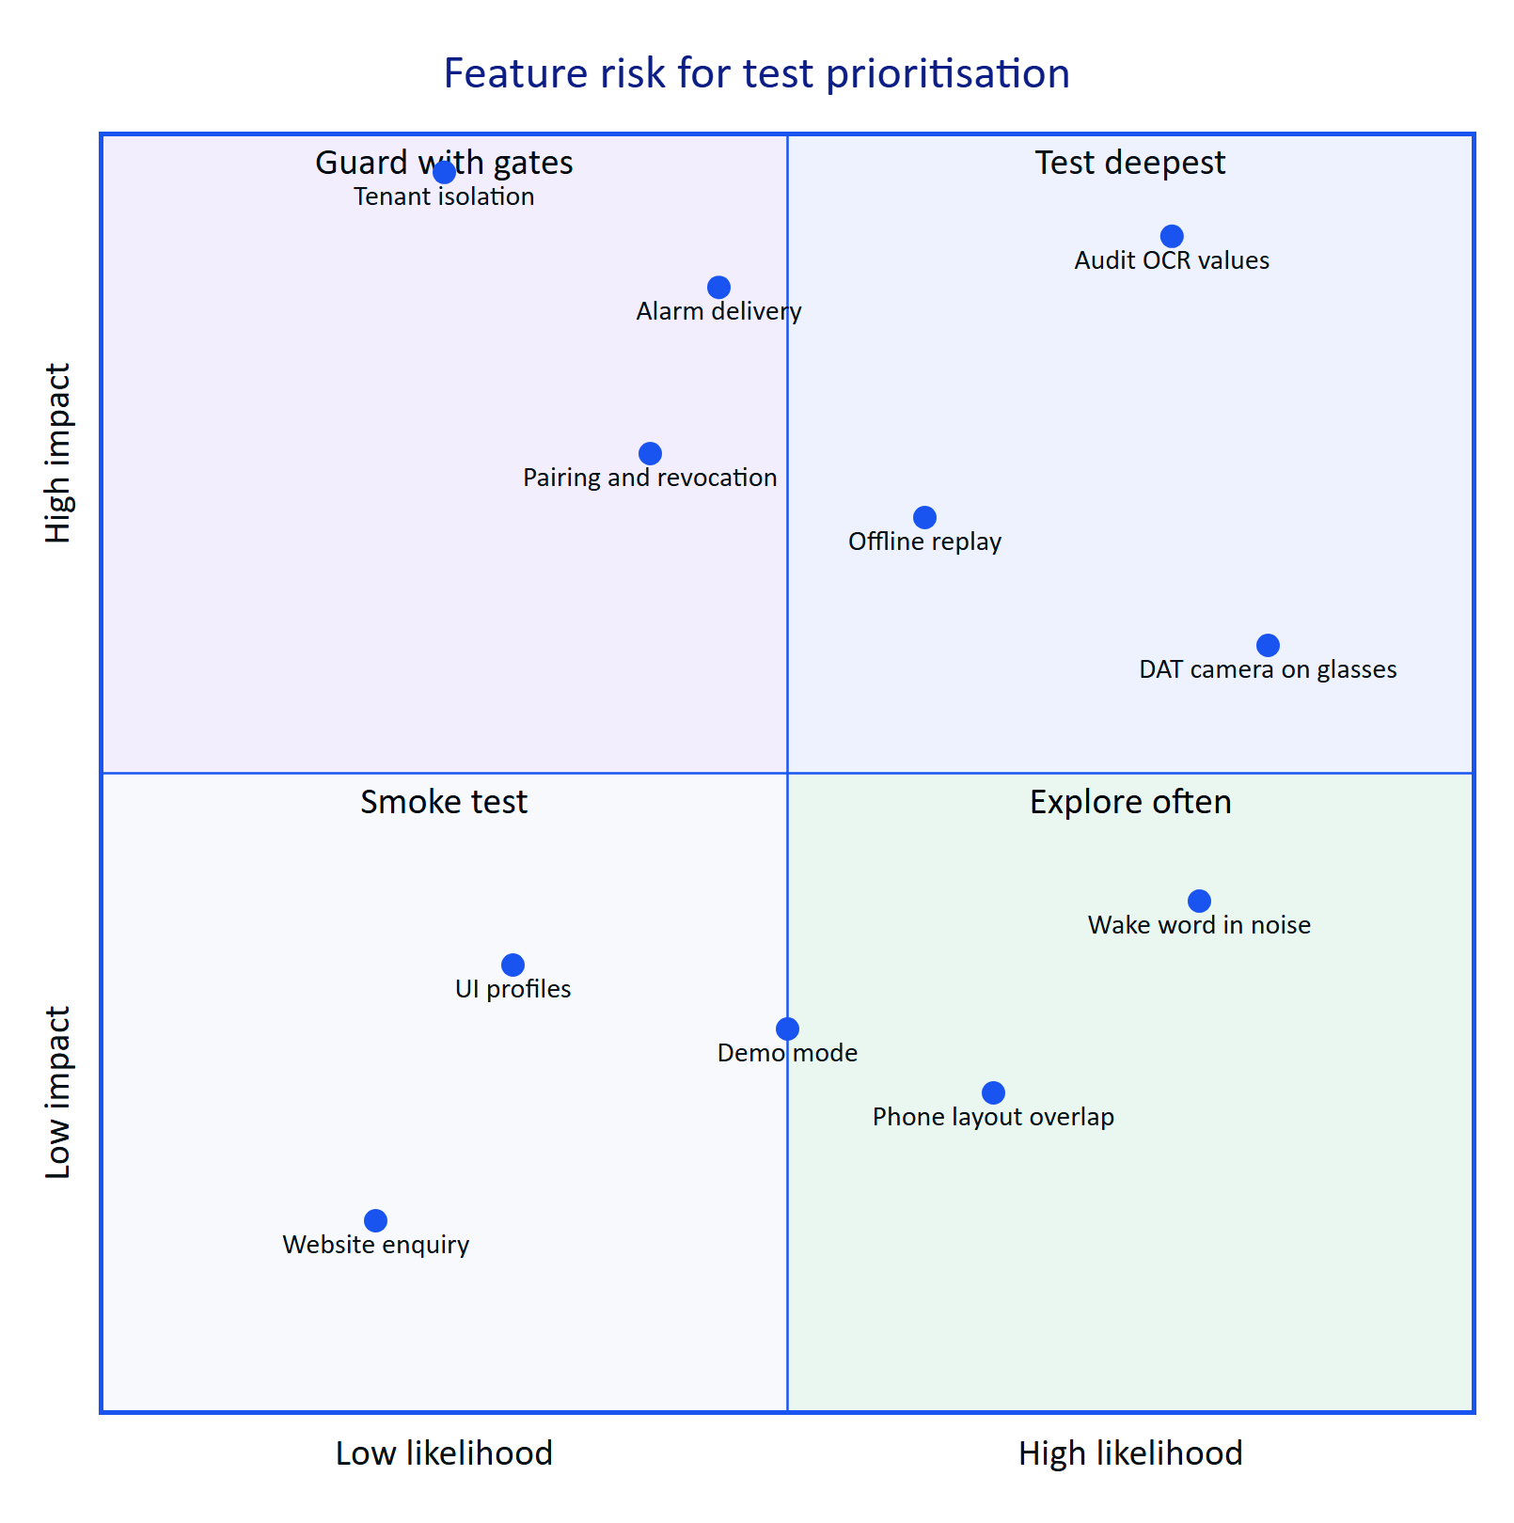
Figure 17. Risk map of feature areas used to weight test effort (team assessment, October 2026)
Table 38. Risk register for testing
Risk | Likelihood | Impact | Test response
A wrong value approved in an audit document | Medium | Critical | OCR benchmark with silent error metric; four-eyes tests; planted-error drills in UAT
Cross-tenant data exposure | Low | Critical | RLS tests, tenant fuzz, pen test
Alarm not delivered to the field | Medium | High | Realtime latency probe, cron schedule fix, SSE reconnect tests
DAT behaviour differs from documentation | High | Medium | Hardware matrix H1 to H4 early; phone-camera fallback kept
Wake word unusable in noise | High | Medium | Utterance benchmark at 85 dB(A); push-to-talk fallback
Offline replay duplicates or loses steps | Medium | High | Offline journey; idempotency tests on client_op_id
Demo behaviour masks a production defect | Medium | Medium | Every release candidate tested on staging

15 Schedule, roles and open questions

15.1 QA schedule
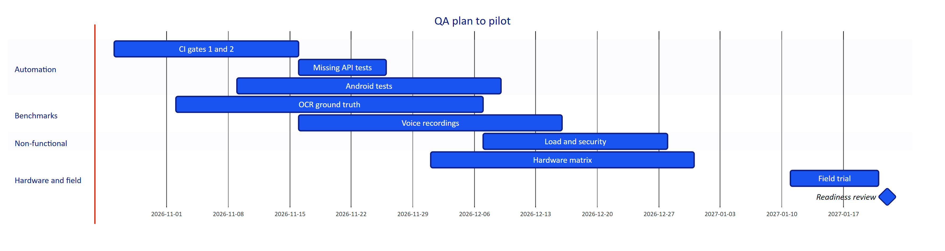
Figure 18. QA activity plan to pilot (plan, dates indicative)

15.2 Roles
Table 39. Roles and responsibilities
Role | Responsibilities
Quality engineering lead | Owns this plan, gates, dashboard and readiness review
Engineers | Unit and API tests with every change; fix defects with regression tests
Mobile engineer | Android tests, hardware matrix execution with QA
QA analyst | Charters, benchmarks, defect triage, traceability
Product manager | Acceptance of criteria, deferral decisions, pilot go or no-go
Customer success | Field trial logistics, operator feedback
Pilot customer quality and EHS | Witness field trials, sign the readiness review

15.3 Open questions
- Will the pilot customer provide real (redacted) log sheets for the OCR ground-truth set, and under what data agreement?
- Is recording plant conversation for the wake false-accept test acceptable to the customer and its workforce?
- Which Ray-Ban Meta generation and which rugged phone will the pilot actually use? The matrix assumes Gen 2 and an XCover-class phone.
- Can DAT capabilities be enabled for testers in India in time for hardware testing (see Glasses Integration)?
- Who signs the readiness review on the customer side: the plant manager, the EHS lead, or both?

